p000
Combinations of n things r at a time are
|n / |r |(n-r)]
[In modern mathematical notation this would be n!/r!(n-r)!
where n! = nx(n-1)x(n-2).... e.g. 5! = 5x4x3x2x1 = 120]
Permutations n things r at a time are n(n-1)(n-2) . . . (n-r+1)
[No of Permutations = n!/(n-r)!]
Permutations of n things all together are [n!]
Possibilities of y crossings 2^y. [2 to the power y, 2^{y}]

Notes on Knots. Vol 4.
HNGB. Ap. 1902.
p001
1
Irregular Knots, with alternate crossings.
Preliminary Investigations as to the connection (if any) between these and the Regular Knots.

For purposes of clear reference in any diagram of a regular knot (2.230 ff) the parts of the bights, if cut, are supposed to be numbered from the top by the right from 1 to x. Thus in the case of S₂ 5b/5c, the numbers would be as follows:--
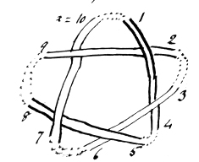 | The same plan can be adopted in the case of any regular knots., and by quoting 2 nos, e.g. 4,5, any particular
bight can be indicated. In forming irregular knots from regular knots, since more than 1 bight must always be cut, the top bight 2-1 is as-
p002
2.
Reversibility.
1z 2z 3z 4z
2c (1B knot) I₂ 2b/2c ✓[hook knot]
3c None
4c I3 2b/4c ✓ [hook knot] I2 4b/4c ✓
5c
6c "A" (6c twist.) ✓ ?I₄ 2b/6c I failed
7c
8c I₅ 2b/8c ✓
9c
10c
11c
12c Twist Knot. ✓

p003
3
sumed to be one of the cut bights in every case.
Provisional Rules.
Let o = an odd no & ε, an even no. in the above system. Let ⊃= joined

(1) o ⊃o +1 }
or ε ⊃ ε -1 } makes a twist & annuls 1crossings

(2) o ⊃o -1 }
ε ⊃ε +1 } restores original bight.

(3) o ⊃o + 2x -1 }
ε ⊃ε -2z +1 } rings (z = S index.)

(4) o ⊃o +2 } encloses 1 loose end involving 1 new crossing & then
ε ⊃ε +2 } cutting of 2 adjacent B outside enclosure.

(5) o ⊃o +3 either encloses 1 uncut B or 2 loose ends involving 2 new crossings
p004
To reverse a twist knot: Slew round etc. 180° & put bight across from right to left or v.v. I could reverse no Turks Head except I₃ 2b/4c nor the Weaver, nor I₂ 6b/6c, nor I₄ 2b/6c.
Probably I₇ 2b/12c is reversible, in which case a series, diff. 4c would be indicated, x = 2 & n is always odd.
See I. p. 152-3.
Every other twist knot of this series 3, 6, 9, 12 etc. (viz 6, 12, 18 etc.) and of the series 4, 7, 10, 13 (viz 4, 10 etc.) are reversible.
? of the 2z series 5, 8, 11, 14. Probably 8 & 14 are reversible. Anyhow I₅ 2b/8c is. Is this a twist knot? The 2z 8c twist is reversible.

p005
5.
(6) ε ⊃ ε + 3 encloses 2 loose ends involving a twist (???able) or 2 new crossings

(7) o ⊃ o +4 } 1 loose end involving 1 new crossing & an uncut B, or 3 loose ends
ε ⊃ ε + 4 } of which 2 may make a twist counteracting the 1 new crossing made by the 3rd, or 3 loose ends involving 3 new crossings

(8) o ⊃ + 5 encloses 2B.

(9) ε ⊃ + 5 encloses 1 B, 2 loose ends.

(10) o ⊃ + 6 encloses 2B, 1 loose end

(11) ε ⊃ + 6 encloses 2 B, 1 loose end

(12) o ⊃ to any other o = o' encloses (o'-1)B

(13) ε ⊃ higher o = o' encloses (o'-2) B & 2 loose ends.

(14) o ⊃ to any higher ε = ε ' encloses ((ε '-2)/2)B & 1 loose end

p006
diagram
p007
7.
(15) ε ⊃ to any other higher ε =ε ' encloses also ((ε '-2)/2) B + 1 loose end.

(16) There is always a loose end when o is joined to a higher o'.

(17) Always 2 loose ends (which may be joined subject to o rules) when ε ⊃ ε '.

(18) For every single enclosed loose end a twist must be supplied by cutting 2B adjacent to one another.

Note: A join, for purposes of description is supposed to be made by the right (as the hands of a clock.) But in effect it makes no difference how it is made. Crossings must be kept alternate.
p008
8. Plait or Twist Knots as on p152ff. of vol 1.
Their reversibility.
The law of reversibility for these knots is as follows:-
Let Σ = any odd no. of strands >1
Then Σ - 1 is the difference of an Arithmetical series of which it is also the first term and in this series every term represents a reversible Plait (Twist) Knot with crossing equal to the term. But except in the case of Σ = 3 the first term duplicates a knot in α (not the) preceding series, and therefore, when all the series are being considered from 3(Σ) onwards, it is best, except with Σ=3, to make 2(Σ -1) the 1st term Thus:
Required reversible knots: Σ ⊃ 5.
Σ = 5, Σ - 1 = 4 = 1st term (since the series alone is being considered.
Ans = 4c, 8c, 12c, 16c, 20c . . . . . knots. (p 9 follows)
p009
9.
Required: Reversibles of 16crossings
Σ differences are 2, 4, 6, 8 etc.
16 is divisible by 2, 4, 8 only.
Values of Σ are 3, 5, 9. 3 knots.
Therefore, except in the case of 2c, of which there is 1 knot, given y (the coefficient of c) there are as many knots as there are measures equal to 2 or multiples of 2 less than y, which will divide y, & values of Σ = these +1.
Example: Required, reversibles of 24.
24 is divisible by 2 Σ = 3 }
and 2 x 2 Σ = 5 }
and 3 x 2 Σ = 7 } 5 = Answer
and 4 x 2 Σ = 9 }
and 6 x 2 Σ = 13 } .

These knots are not necessarily on 1z.
Determination of z.
In Σ = 3, z = 1 except in the case of 2c, 2 + 6c (or a multiple of 6c), in which case z = 2.
Every 3rd knot is on 2z. 1st = 1 (Σ-1)c
(p 10 follows)
p010
10.
Σ = 5. (4c z=1) ✓
8c z=3 ✓
12c z=1 ✓
16c z=1 ✓
20c z=1 ✓
24c z=1 ✓
28c z=3 ✓
32c
Every 5th knot is on 3z. 1st 3z = 2(Σ-1)c

Σ = 7.
(6c z = 1) ✓
12c z = 1 ✓
18c z = 4
24c z =
30c z =
36c z =
42c z =
48c z =
54c z =
60c z = 4
Every 7th is on 4z. 1st 4z = 3 (Σ-1)c

p011
11.
Examination of S₂ ^{5b}/_{5c}.
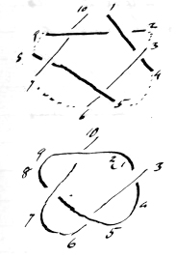
Let B 10.1 be cut.
Join 1, 2. A twist is formed annulling a crossing thus:-

If 10 & 3 are ⊃ no new C is made to compensate but I₂ ⁴/₄ results.
If one of them is taken under & over the new B 2 new C result.
Let 3 be taken under & over to 10.

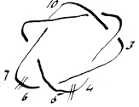
There are now 6C on 2 cords (S₂ ^{6b}/_{6c}) which can be reduced only by cutting 2 adjacent B.
Cut 4, 5, & 6, 7. & join 5, 6, to make a twist.

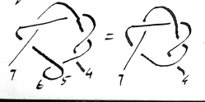
There are now 5C again.
Join 4, 7.
Result: Original Knot.

p012
The law for determining z is this:- In any series Σ (where Σ = no. of strands), the reversible having (( Σ-1)²/2) c, and those having this no. of c + Σ(Σ -1)c or + any multiple of Σ(Σ -1)c are on (Σ +1)/2 z and the others are on 1z.
Thus: Required reversibles on 1z, 8c.
8 is divisible by 2, 4
Values of Σ = 3, 5
Σ = 3. ((3-1)²/2) c = 2c
Σ(Σ -1)c = 3(3-1)c = 6c.
2c + 6c = 8c. But this then is not on 1z, and is no good.

Σ = 5 (5-1)²/2 = 8c. This then is no good.

Ans: No Σ 8c twist reversible on 1z.

p013
13
Suppose however 6, 7 & 8, 9 had been cut & 7 ⊃ 8, 6 ⊃ 9. Then also the result is the same, viz Original Knot.
Next begin by ⊃1 & 2 as before, & join 10, 4 & 3, 5, keeping the C alternate where the new C is made, thus:-
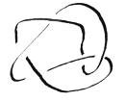
This knot results which is a new irregular knot of 5C, viz the Timber Hitch, which may be represented
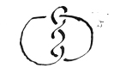
It is found by experiment that this same Turks Head can be obtained by the following processes:-
1 ⊃ 2 3 ⊃ 5 10 ⊃ 4
1 ⊃ 3 2 ⊃ 8 10 ⊃ 9
1 ⊃5 3 ⊃ 4 10 ⊃ 2
1 ⊃7 6 ⊃ 8 10 ⊃ 9
1 ⊃ 9 7 ⊃ 8 10 ⊃ 6
1⊃ 8 4 ⊃ 6 5⊃ 7 10 ⊃ 9.
p014
Reversibility of Links
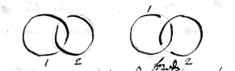
Revolve top of 1 down forwards, 2 steady.
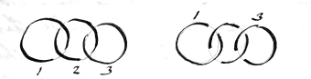
Revolve top of 1 down forwards, 2 steady, revolve top of 3 up.
And generally when thus placed at first, revolve alternates. If the links are thus:-
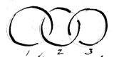
simply revolve bottom of 2 up.
In all these cases the links can be connected only in one way
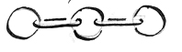

p015
15.
Hence there are only 4 nos, to which 1 cannot be joined, viz itself 1; 10, restoring original B; 4, necessitating a ring & ∴2 cords; & 6, do. In the case of 4 this is obvious, & it is easy to demonstrate in the case of 6. For join 1,6.
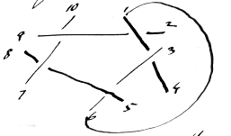
Then if 3, 4 are joined there is a ring. If none of 2, 3, 4, & 5 are joined to one another there will be 4 new crossings & it is only possible to make 2 twists. Therefore 2 of them must be joined. It is immaterial which 2 are joined. Join 2,3.
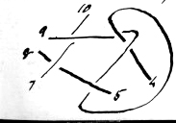
If 4 & 5 are not now joined there must be 2 new C & ∴ 2 twists. But if 2 twists are made by joining 7 8, 9 10, nothing is left to

p016
As to I_{z} Reversibles
of the series 2, 8, 14 &c.
20, 24, 28 appear in other series, but with regard to 2 it is certain it cannot be on I_{z} except as an unguarded twist. With regard to 14c it cannot occur as a twist plait knot on any but 2z. With regard to 8c it cannot appear as do. on any but 2z or 3z, but it does appear as I₅ 2b/8c. Now of what series does this knot form a part, and can it include 14c ?
Values of x, with y = 14, are 3, 8.
We have
(z = 1) I₃ 7b/14c, I₈ 2b/14c (z = 2)
(z = 1) II₃ 7b/14c (VII₈ 2b/14c reducible)
There are therefore 3 knots.
Note that I₂ 2b/2c, I₃ 2b/4c, I₅ 2b/8c are reversibles. I don’t feel sure that I₄ 2b/6c (2z) is not so. But the only two regulars on 1_{z} are I₃ 7b/14c & II₃ 7b/14c.
Examination shows conclusively that I₃ 7b/14c is reversible.
p017
join on to 4 & 5. Therefore join 4, 5.
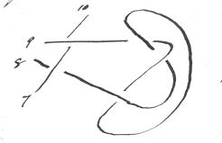
Now if 10 is joined to 9, 8 must be joined to 7 & 2 crossings are annulled. ∴10 must be joined to 7 or 8. It cannot be joined to 7 or a ring will be formed. ∴join 10 to 8 & 7 to 9. But 2 new crossings will result. Therefore 1 cannot be joined to 6 Q.E.D.
It appears from the foregoing that provided a twist & a l. end are formed, & the l. end joined to the remaining end, the Turks Head will always be formed from S₂ ^{5b}/_{5c}.
Tait says there are only 2 1-cord knots of 5c, & no doubt S₂ ^{5b}/_{5c} and the 5crossings Turks Head are those knots.

p018
I find all the r.ks up to I3 7b/14c are reversible, & hence it may be safely inferred that all I3 are reversible. The only knots in I3 that coincides with plait-twists Σ = 3 is I3 2b/4c. The others are different.
It is possible therefore that all in I5 are reversible. And in I7. Also that all II3 are reversible, & so forth. No: II3 4b/8c was not reversible. But in I5, 2b/8c, 3b/12c, 4b/16c, 6b/24c were all reversible, and probably it may be safely said that all I5 are so. Further, probably all with n odd of I are so.

p019
It is possible to represent S25b/5c in long form thus:-
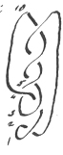
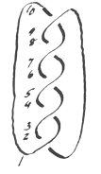
Now join1, 2; 4,10; 3,5 The result is obviously the 5crossings. Turks Head

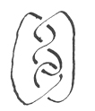
It might be thought that:- obtained by ⊃ 1 8, 9 10, 4 6, 5 7 (turned upside down) was a new knot, but it is clear that by untwisting the bottom twist, a new twist is added to the top, & the Turks Head results.

Evidently 2 or more unguarded twists at each end are unstable & can be added on to the reverse end from either until the guard is reached. By a guard is meant a cord passing through a bight above the twist or below it, thus:-
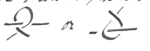

p020
[Blank except for the following lines in pencil] And “A1” ii. 100 – 1. I [wld?] I think [srihoh?] Reef & Granny
p021
Examination of Irregular Knots of 6 crossings.
There is no regular knot on one cord of 6 crossings except the Twist, because the factors of 6 are 1, 2, 3 & 6 giving n as 2, 3,4 & 7, all of which except 7, the twist, have measures in common with 6. (The same applies to knots of 1 & 2 crossings.)
It is known that a knot of Turks Head form corresponds to every no. of crossings. of 3 & upwards (that of 3 being a r. knot S2 3b/3c & that of 4 being S3 2b/4c). Hence there is a Turks Head of 6 crossings. Further the Granny, the Reef & the Weaver (or Bowline, or Crossed Running Knot) are other knots of 6 crossings. on one cord. Tait says there are only 4 such knots.
Problem: To derive these 4 knots.
From regular knots. of 6 crossings. From S2 6b/6c the Reef is obtained by joining 2,4; 1,3; 5,6; 12,7. In the form of 2 dissimilar overhands on and endless cord. From do. the Granny
p022 blank

p023
23
on 1 cord is obtained by joining 1.b; 12.7.
From S₄ ^{2b}/_{6c} the 6.c T.H arises by untwisting 1, 2, 3, 4; 1 & 2 being joined and 3 & 4 joined through their bight. From S₃ ^{3b}/_{6c} the Weaver [G?] can be made by joining 1,4; 3,5; 2,6; of which 3,4 are untwisted while 2,6 give the new crossing. The Turks Head is made thus
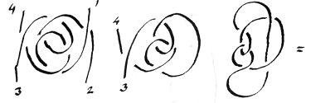
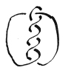
Compare p19.H for the 1st form of the Turks Head here shown.

But can S² ^{6b}/_{6c} supply the Turks Head & the Weaver as well as the Reef & Granny?

p024 image only
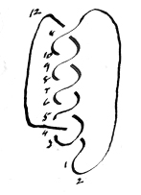
p025
25
It is possible to represent S² ^{6b}/_{6c} in long form thus:-
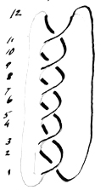
Proceed on analogous lines with the plan on p 19 & join 1,2.
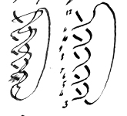

There are now 5c & a new one must be made. This can be done by joining 3,5; 12,4 as before, when the Turks Head on 1 cord with 6crossings. results. In both cases 1,2; 3,5; & 2,4 were joined to produce the Turks Head
∴3 out of 4 possible irregular knots have been obtained from S² ^{6b}/_{6c}: can the Weaver be got in some similar way?
It can be done as follows: Join 1,2; 3,4; 4, 7; 6, 10; 11,12. The stages are as
p026 blank
p027
27
follows:-
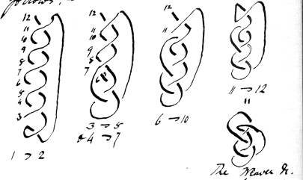
In the above process 8,9 is the only bight not cut. The operation is [?] complicated that it is going rather far to say that the one knot is or can be derived from the other. On the other hand the T. H. is fairly derived both on pp 19 & 25. It would be curious if in the case of any knot in S₂ whether on 1 cord or more, a single cord Turks Head with the same no. of crossings as the knot could always be produced by joining 1,2; 3,5; 4 &c. Try this. Proved in case of S_{z} ^{5b}/_{5c} (z = 1), Sz ^{6b}/_{6c} (z = 2)
p028
[2?] K regular knot.
p029
Join 1,2; 3,5; 2,4; in S₂.
There is still no 5 till we get to S_{z} ^{3b}/_{3c} & this is really a Turks Head already. But if the process is applied, result is the reflection of the knot. (z=1)
S_{z} ^{4b}/_{4c} (z=2) Result, Figure 8 on 1x (a Turks Head)
S_{z} ^{5b}/_{5c}, 5c Turks Head (z=1) p 19.
S_{z} ^{6b}/_{6c} (z=2): 6c Turks Head (z=1)
S_{z} ^{7b}/_{7c} (z=1): 7c Turks Head (z=1)
S_{z} ^{8b}/_{8c} (z=2): 8c Turks Head (z=1)
Therefore this general rule may be laid down: An irregular knot, the Timber Hitch of the same no. of Crossings as any knot in S₂ with more than 2 crossings, can be obtained on 1 cord, [__ing?] other methods by joining 1,2; x,4; 3,5, and in the case of S_{z} ^{3b}/_{3c} it is merely another form of the regular knot and in the case of S_{z} ^{4b}/_{4c} it is
p030 blank
p031
another form of S₃ ^{2b}/_{4c} a regular knot so that in these two cases the regular knot & irregular knot overlap. In other words there is no irregular knot of 3 or 4c on 1z, but these two knots can be displayed as regular knots or T.Hs.
Query: Does the Turks Head come within the definition of a regular knot No: I think not, except of course 2₃ ^{3b}/_{3c} and S₃ ^{2b}/_{4c} rearranged. Since the no. of knots in any S is infinite, & S_{z} contains knots of all possible crossings, ∴ all the T.Hs. can be derived from the S₂ regular knots, & this disposes of one class of irregular knots, the rule above laid down applying to all of them.
Query: Can the rule on p29 be stated in more general terms on the lines of p17.M? Thus can be said that in any Sz knot if adjacent parts lying in two bights are joined, & 2 other parts
p032 blank
p033
joined over a loose end, & the loose end joined to the remaining free part, that the rule holds good? It has been shown so in S₂ 5b/5c - Take S₂ 6b/6c where Z = 2.
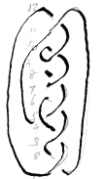
Join 10, 9, 4, 6; if 5 is joined to 11, there still remain 7 & 8 to be dealt with. But they must not be joined or a twist will result.
Can it be said that if the twist is made, & the parts on each side of it joined, & the parts on each side of these again joined through the new bight a Turks Head will result? No. There remain uncut bights.
The rule however may be stated more generally thus:- Any knot in S2 with 3 or more crossings can be converted into an irregular knot in the form of a Turks Head on 1 cord by cutting

p034 blank
p035
any 3 adjacent bights, joining 2 adjacent parts, each in a different bight (thus making a twist) joining the part farthest away from the twist within the half circumference to the part nearest to the twist on the same side of it, and joining the remaining outside parts, on either side of the uncut bight or bights, keeping the crossings alternate. (It will be noticed on p13 that all the 3 bight methods deal with adjacent bights.) With regard to the formation of the granny (pp21-3) it will be noticed that every alternate 2z knot in S₂ has opposite bights on different cords. Such knots are 2b/2c, 6b/6c, 10b/10c etc. while the knots 4b/4c, 8b/8c, 12b/12c, have them on the same. Hence it may be laid down as a general rule that: An irregular knot may be formed with the same no. of crossings on 1z from every knot in S₂ (except 2b/2c) with
p036 blank
p037
an even no. of crossings not divisible by 4 by cutting joining the nearest sides of two opposite bights. (In the case of 2b 2c an irregular twist results.) Also in those even crossings knots divisible by 4, an irregular knot on (2 + 1) = 3z by the same process, and on (2 + N)z when N pairs of opposite bights are joined in such knots.
With regard to the formation of the reef knot, it may also be laid down that “An irregular knot may be formed with the same no. of crossings on 1z. from every knot in S₂ (except 2b/2c) with an even no. of not divisible by 4 by cutting 4 adjacent bights, joining 2 adjacent parts of adjacent bights, joining an odd to an odd & and even to an even part (in the same ½ circ. as the twist) & joining the 2 parts on either side of the uncut bight or bights.
For example, take S₂ 10b/10c :-
p038 blank
p039
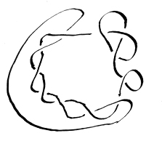
so with regard to the weaver, it may be said, From any S2 knot with even crossings indivisible by 4, an irregular knot may be formed by cutting 5 adjacent bights, say x – 1 to 8 – 9, & joining 1, 2; 3, 4; 5, 7; 6, 9; & x, 8;
It appears probable that for every additional bight cut, an additional irregular knot could be formed in the case of S₂ knots with even crossings indivisible by 4, in which case it might be said that the no. of irregular knots capable of being formed from such knots is B-2, giving 4 for S₂ 6b/6c, 8 for 10b/10c, 12 for 14b/14c & so on.

p040 blank
p041
2 B must be cut to get the first irregular knot, & one B must be left apparently uncut. Tait says there are 8 knots with 7c. Two of these are the regular knots S₂ 7b/7c & the 7c. Turks Head What are the other 5 on 1z? And why is it that only 1 irregular knot can be formed from S₂ 5b/5c & 7 irregular knots from 7b/7c ? According to Tait’s series the knots are
5c 2k
6c 4k
7c 8k
The series 2, 4, 8 may be continued 16, 32, 64, & so on, but it seems improbable that this should be so. If however it is so, it smashes the B-2 theory above.
p042
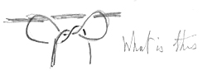
What is this

Cf V. 203.

If the ring in the knot opposite were a metal ring & the cord cut at the twist, this knot would form rather a good mooring knot of the Larks Head order, thus:-
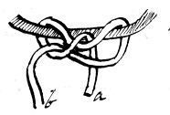
Either end may be strained & I believe this to be a new hitch. If a were taken through the left hand bight it would form an ordinary running knot. If through the right hand bight, a figure of 8. If, instead of a, a bight were put down, it might serve as a signal hitch etc. since on pulling a out & straining b, the hitch runs out.
p043
In any knot of S₂ the effect of a twist & join over it (2 adjacent B cut) is to reproduce the knot preceding it in the series. Try effect on S₃ 4b/8c
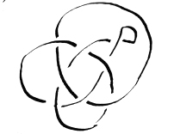
Here an irregular knot of 7c on 2z is produced. a circle interlaced with [???]

By cutting the twisted bight & the circle bight & joining the following plait is obtained on 1z, 7c.
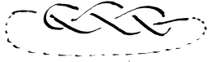
This cannot be joined up & made into

p044blank
p045
45 a regular knot without obliterating 2c. Of course this plait could be obtained directly from S₃ ^{4b}/_{8c} thus :- Here on a 1z knot 2 adjacent bights have been cut & the alternate parts x & 2, 1 & 3, joined without alternate crossings, producing an irregular knot of c – 1 crossings = 7 on 1z. Therefore among knots of 7c are S₂ ^{7b}/_{7c}, the T.H; & this irregular knot plait. Presumably every 1z. k in S₃ could be similarly made to produce an irregular knot. on 1z. with 1c. less than the number. (S₃ ^{5b}/_{10c} & S₃ ^{7b}/_{14c} can.)
p046 blank
p047
47 Question of rings. See p91. A ring is formed in the following cases:-
S₂
2b/2c no 1 & no 4 (exists as such)
3b/3c 1,4.
4b/4c 1,4; - 1,8 (exists)
5b/5c 1,4; 1,8
6b/6c 1,4; 1,8; - 1-12 (exists)
7b/7c 1,4; 1,8; 1,12; & so on from which it appears that any part with numeral y joined to any other part with numeral y + (M₂ x n-1) gives a ring.
S₃
3b/3c 1 + 6 (exists)
4b/8c 1 + 6
5b/10c 1, 6;
p048 blank
p049
(S₃ cotd)
6b/6c 1,6; - 1,12 (exists)
7b/14c 1,6; 1,12;
8b/16c 1,6; 1,12;
9b/18c 1,6; 1,12; - 1,18 (exists)
10b/20c 1,6; 1,12; 1,18.
& so on, from which it appears that any part with a numeral y joined to any other part with numeral y - (M₂ x n) – 1 gives a ring.
May the formula be stated generally thus:- Rings are formed when x is joined to (M₂ x n) – 1? (M2 being any multiple of 2)
Take S₄ 6b/18c . Here 1 + 4, 12 + 5 give rings. According to the rule, 1 + (M₂ x 4) gives any rings, i.e. 1 + 8, 1 + 16 &c. Here 1 + 8 does give a ring. 1 + 16 does not exist. The rule holds good, but is not comprehensive enough.
p050
p051
1 + 4 points to S2, & it is to be noted that S₄ ^{6b}/_{18c} is on 2z.
In S₄ ^{9b}/_{27c}, 1 + 4 also gives a ring though this is on 1z.
It looks as though the rule applying to S2 applied also to S4 and that the rule ought to be stated thus:-
Let P be any prime factor of n - greater than unity. (It may equal n.) Then rings are formed by joining x to (M₂ x P) – 1.
Test this with S₆ ^{11b}/_{55c}. A priori since P may be 2 & 3, one would expect that
+ 1 + (1 x 2 x 2) – 1 = 1 + 3 no
1 + (1 x 2 x 3) – 1 = 1 + 5 no
1 + (2 x 2 x 2) – 1 = 1 + 5 no
1 + (2 x 2 v 3) – 1 = 1 + 11 no (Rule breaks down)
+ 1 + (4 x 2 x 2) – 1 = 1 + 15 no
1 + (4 x 2 x 3) – 1 = 1 + 23 non existent
1 + (6 x 2 x 2) – 1 = 1 + 23
1 + 12 ring = 1 +

p052 blank
p053
Has it anything to do with the number of times 2 or M₂ will go into C? Thus there are here 22c, & the added number is (²²/₂ + 1) = 12.
But this would not suit S₂ where the crossings are often odd. In S₆ ^{9b}/₄₅ it is obvious that 1 + 6 gives a ring.
It appears that in joining S₆ 1 + 6, 1 + 12, 1+18, & so on give rings, i.e. 1 + M_{n}.
The same may be said of S₂ when z = 1.
In all the series the part numbered 1 regains the circumference at 2n & 4n & 6n counting round from the right & counting 1 for each part gone by. The question is how to state
p054 blank
p055
this fact as a rule so as to embrace the cases where it emerges e.g. a 2nd time in between its first reappearances. It depends on the no. of bights.
Take S₄ 6b/18c 12 parts.
Rings are formed at
1+8(2n)
1+16(4n)=1+4n-12
Take S₆ 11b/55c
Rings are formed at
1+12(2n) =1+12
1+24(4n) = 1+4n-22 =1+2
1+36(6n) =1₁+6n-22 =1+14
1+48(8n) =1+8n-22 =1+26 non existent.
Therefore the rule may be stated thus: Rings are formed when any part numbered y is joined to
y - (M2 x x) -1, or, where M2 exceeds 2B, to
p056
Usually y=1 to begin with, in which case this practical rule is:
Don’t join 1 to (M2 x n) or to (M2 x n)-2B. & no M of 2 need be considered which gives a value for the second part higher than 2B, because such parts do not exist.
p057
y + (M2 x n) - (1+2B).
But in the case of S₂ with 1z, a ring is formed by joining 1+2, and not where z=2. This apparent exception is met by applying the 2nd part of the rule.
B = C/(n-1)
∴2B = 2C/(n-1)
Hence the Rule of Rings may be stated thus:-
A ring is formed when any part numbered y is joined to any other part the number of which = y+(M2 x n) - 1, or to any other part the number of which = y+(M2 x n) - (1+2C/(n-1)), and for 2C/(n-1) may be substituted 2B. Therefore in forming irregular knots with 1z it is necessary to set out all the parts existing comprehended in this double formula as prohibited joins.
p058
Since x=2B=2c/(n-1), more simply thus: Don't join 1 as forbidden on p 56 nor must it equal (M2 x n)-2. But x is always even: ∴these last 2 expressions can never be odd. x+(M2 x n) - 2 can not exist. But (M2 x n) – 2 = M2 [?] No. no.
p059
With regard to this rule it is to be noted that 2 parts cannot be joined without 2 other parts being joined. Therefore if only 4 parts are to be joined (the minimum number) i.e. if only 2 bights are cut, the joining of the complements of these parts would necessitate the rule being broken in the 2nd join. In such a case therefore, where only 2 bights are cut & y=1, to the working rule on p.56 must be added this:- The no. to which 1 is joined must not come within the formula on p. 56, nor must it, when even, be such that it equals x+(M2 x n)-(2+2C/(n-1); the primary formula will be broken in the case of x, where x = the part numbered 2B.
p060
p061
The complete working rule for joining 1 where 2B are cut (which may or may not be adjacent is):- Don't join 1 to
M2 x n
(M2 x n) - 2B
(M2 x n) -2
M2 being any multiple of 2, which it is no good to consider when any of these 3 expressions represent a number equal to or higher than 2B (=2C/(n-1)). If such joins are made, rings will result. M2 x n may be written "M2n" when the 3 prohibitions are
2Mn or M2n
2(Mn-B) or M2n-2B
2(Mn-1) or M2n-2
Unfortunately the rule breaks down since S₆ 12b/60c shows that there is only 1 exclusion. But it may perhaps hold when z=1 to begin with.
p062
p063
When z exceeds 1 a rule may be stated thus:- The no. of ring-giving joins is (B/Z)-1
(By ring-giving is meant that the no. of Z is increased.)
Cases where Z exceeds unity
S₂ 4b/4c 1 exclusion (4b/z) – 1 = 1 viz 2x
S₂ 6b/6c 2 ex. (6b/z) – 1 = 2, 2n (4), 4n (8) & so on.
S₃ b/6c 0 ex (3/3) – 1 = 0
S₃ 6b/12c 1 ex (6/3) – 1 = 1, 2n (6)
S₃ 9b/18c 2 ex (9/3) – 1 = 2, 2n (6), 4n (12) & so on
S₄ 6b/18c 2 ex (6/2) – 1 = 2 , no 4 (4n-2B), no 8 2n
p064 blank
p065
(Rule of Rings) p91
In any regular knot the number of ways in which any 2 bights may be cut and have their cords rejoined so as to increase the existing value of Z by forming an additional Z (or "ring") cannot exceed (B/Z) - 1,
(or (C/(Z x (n-1)) -1), A ring is formed when any part in such a case numbered y is joined to any other part the number of which is y + M2x - 1 or y + M2x -(1 + 2B) (= y + M2x - (1 + 2C/(n - 1))) or y+M2x - 3 (as in this case the complementary part of y's bight would come within the first part of the rule), provided always that the number of cases is limited to (B/Z) -1, and that the values of the part-numerals obtained by this formula are the first ((B/Z) -1)) one or more in order of arithmetical greatness.
p066 blank
p067
Where 1 = y, exclusions under this rule are:-
M_{2n}
M_{2n - 2B}
M_{2n - 2}
where M is any multiple: but subject to the rule that there are no more such values than B/2 - 1, and further that these are taken in order of arithmetical magnitude; and of course, since x = 2B, no value can equal or exceed 2B.
Test this rule with S₅ 12b/48c, z = 1.
B/z - 1 = 12/1 - 1 = 11.
M_{2x}= Mx10 = 10, 20, [30 exceeds 2B]
M_{2n - 2B} = M x 10 - 24 = 6, 16, [26 exceeds 2B]
M2n = 2 = 8, 18, [28 exceeds 2B]
∴the prohibitions are 6, 8, 10, 16, 18, 20
p068 blank
p069
This test is found to confirm the rule.
Next take S6 8b/40c. z = 2
B/z - 1 = 8/2 - 1 = 3
It is obvious that there are 3 cases = 4, 8, 12.
M2n = M12 = 12, [24 exceeds 2B]
M2n - 2B = 8, [20 exceeds 2B]
M2n - 2 = 10, [22 exceeds 2B]
Of these 12 & 8 are right; 10 is wrong.
Therefore strike out the (M2n - 2) part of he rule & state the exclusions thus
M2n
M2n - M'B
where M & M' stand for any multipliers which may be the same or different.
The rule thus stated meets the cases of both S5 12b/48c & S6 8b/40c. Test it further.
p070 blank

p071
Take S4 6b/18c z = 2
Here it is clear by inspection that there are 2 exclusions, 4 & 8.
B/z - 1 = 6/2 - 1 = 3 - 1 = 2 ✓
M2n = M x 8 = 8, [16 exceeds 2B]
(M2n = 8, 16, 24, 32, 40 &c.
(M'B = 6, 12, 18, 24, 30, &c.
The rule won't work thus.
M2n - 2B = 8 - 12 [??]
16 - 12 = 4 ✓
24 - 12 (equals 2B].
The rule stands without the 3rd exception, though that seems to apply when z = 1. But even then it won't cover the 4 in S6 8b/40c
Test the rule as given on p 67 with S4 9b/27c, z = 1
M2n = M x 8 = 8, 16, [24 exceeds 2B]
M2n - 2B = 6, 24, [22 -------
M2n -2 = 6, 14, [22 ------
B/2 - 1= 8. Exclusions are 6, 8, 14, 16
p072 blank
p073
The rule holds but the numbers overlap.
Take S4 11b/33c
n = 4, B = 11, z = 1, 2B = 12
B/2 - 1 = 11/1 - 1 = 10.
M2n = M8 = 8, 16, [24, 32, 40, 48,
M2n - 2B = 2, 12 10, 18 [26 ------
M2n - 2 = 6, 14, [22
∴exclusions are
2, 6, 8, 10, 14, 16 & 18.
4 12 20
In this case they turn out to be all the even nos, & the rule breaks down.
I believe in every case of 1z, 1 added to an even no. gives a ring. For there are 4 parts cut, and the parts are even & odd alternately from arc to arc. Therefore an odd cut part will be even in the first bight it emerges in, odd in the 2nd, even in
p074
Let M = any even multiplier & O = an odd one.
Exclusions are O2n & M2n + 1 [bracketed with] or do. - 2b which make rings.
Values not to exceed 2B, group limited by B/z - 1
Exclusions are
2 x 2n (even)
(2 x 2n) + 1
3 x 2n
(4 x 2n) + 1
5 x 2n
(6 x 2n) + 1
p075
p076 blank
p077
The part 1 emerges in the nth bight from its own, in the 2nth, in the 3nth, the 4nth etc. Does it emerge as an odd or as an even no? In S₂ 4b/4c, 1 emerges as 4 (= 2n) in the nth bight from its own. In S₂ 5b/5c as 4 (=2n) in the nth bight & as 8 (= 2 x 2n) in the 2nth bight. Throughout S₂ 1 emerges always as an even no. Therefore in S₂ the exclusions are M2n. & these only, & the (B/Z)-1 rule limits their no. In S₃ 1 emerges in the nth bight from its own, in the 2nth, 3nth & so on. It emerges as an even no (except in S₃ 3b/6c where there can be no prohibitions) In S₄ it emerges as an even no. So
p078 blank
p079
in S₅. So in S₆. Therefore it would seem that in any S, 1 must not be joined to M2n, but this must be reduced where necessary by subtracting 2B. i.e. values of M2n are to be taken up to 4B-2, & 2B subtracted from those above 2B.
Take S₅ 12b/48c z=1
n=5, b=12, 2B=24, (B/z)-1=11
M2n are 10, 20, 30, 24, 40, 50
-24 -24 -24
=6 =16 =26
giving 6, 10, 16, 20. But this omits 8 & 18 (p67. B.)
In point of fact 1 joined to any even no. in S₅ 12b/48c gives rings.
Where z=1, it seems obvious that as 1 passes into every bight & emerges as an even no, previous to emerging as x, if it is joined to any even no.
p080 blank
p081
other than x it must form a ring. But this is not the case when z is greater than 1. Can this be proved theoretically? 1 emerges in the nth, 2nth, 3nth bight etc. & where these exceed B in these bights less B. (The nos. of its parts are 2n, 4n, 6n, 8n etc. less 2B if necessary.
Nos. are M2n & M2n-2B up to 2B.
Where n=2 & B=3 we have
4, 8, 12, 16, 20, 24, 28
-6 -6 -6 -6
=4 =2 =6
Here we have 2, 4, 6 - all the even nos up to 2B.
Where n = 2 & B = 5
M2n= 4 8 12 16 20 24
-10 -10 -10
=2 =6 =10
and here we have them alloose These are both in S_{z}.
p082 blank
p083
Take S₃ 4b/8c 2B=8
M2n = 6, 12 18 24 30 36
-8 -8
=6 =4 =10
Here we have 4 & 6 only. Yet 2 gives a ring. Divide B by n. If there is no remainder the exclusions are 2n, 4n, 8n etc. up to 2B. If there is a remainder it represents a certain no of bights less than n to the left of x. Under these the line will pass & emerge in the (nth from x - this remainder) bight, then in the (2nth - this remainder) bight & so on. Therefore to the even no. in that bight it must not be joined. i.e. to 2 (n-r) 2(2n-r) &c. or M2(n-r.) up to 2B. And if there is still a re-
p084 blank
p085
mainder it will continue to 2(n-r'), 2(2n-r') etc. until there is no remainder.
Take S₆ 12b/12c.
Divide 12 by 6 = 2: no remainder. Exclusions = 12, 24 (=2B.)
Take S₆ 10b/50c. Divide 10 by 6 = 1+4
2B = 12. Exclusions are 2n(=12)
It may be said at once that the first exclusion is 2n, the 2nd 4n, the 3rd 6n, the 4th 8n, but where one of these nos. equals x, there the thing ends, i.e. if 2B is divisible by 2n (i.e. B by n). But if it is not then the next exclusion after the one lower than 2B is the difference from 2B + balance of 2n, i.e. it is a sum equal to 2n.
Take S₆ 10b/50c. First exclusions are 12, 24etc; but 20 - 12 = 8 & 2z - 8 = 4
p086 blank
p087
(= 2n-r, where r is remainder). This 2n-r = 4. Next exclusions are 4, 16, 28 etc.
But 16 from 20 = 4 & (2n - 4) = 12 - 4 =8.
Next exclusions are 8, 20 Now 20=2B, & that ends it. Therefore total exclusions are 12, 4, 16, 8 or 4, 8, 12, 16. This is correct.
Therefore the Rule of Rings may be stated thus:
Where z = 1, an odd no must not be added to an even no, nor an even no to an odd;
where z exceeds 1, if B is divisible by n, then 2n, 4n, 6n etc. up to 2B are excluded;
where B is indivisible by n, then (1) 2n, 4n, 6n &c up to 2B are excluded & the r difference, d, of whichever of these nos is next below 2B subtracted from 2n, & this no. +2n, 4n &c. are excluded & so on till a number is reached which equals 2B.
p088 blank
p089
Query: Is it a series of which the difference is always 2 x the G.C.M. of B & 2? Thus in S6 10b/50c the G.C.M of 6 & 10 is 2, & 2x2=4.
In S6 12b/60c, the GCM is 6 & the double is 12.
In S6 9b/45c, the G.C.M. is 3 & the double is 6.
In S6 11b/55c, the GCM is 1 & the double is 2.
In S5 10b/40c, the GCM is 5 & the double is 10.
In S5 11b/44c, the GCM is 1 & the double is 2.
In S5 5b/20c, the GCM is 5 & double is 10.
In S4 6b/18c, the GCM is 2 & the double is 4
Yes.
p090
? Is it true that y joined to y-1 + Mn,z in any Series n, gives rings? No -
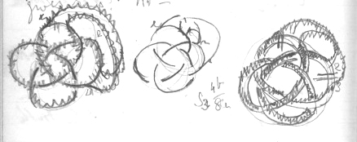
S3 4b/8b

In S2 7b/7c there are 16 parts 1 + 1 [?:suit] 2=1 M2z = M1 = 2, 4, 6, 8, 10, 12, 14 leaving 3 5 7 9 11 13 = 6 other cases, & length. This would give 7 h, but Tait says there are 8
In S2 5b/5c there are 10 pts.
M2z= 2, 4, 6, 8, 10 leaving 3 5 7 9 so 4 other [? rings] but Tait says there are only 4 knots.
Test the knots so formed.
p091
The Rule of Rings is this in all cases: 1 must not be joined to M₂ (GCM of B&n)= M2 (GCM of C/n-1 + n) or y must not be joined to y-1 + M₂ (GCM of B&n)= y – 1 + M₂ (GCM of C/n-1 + n)
But by XIV. (ii.267) the GCM of B & n = z. Therefore the Rule of rings is only 1 must not be joined to M_{2Z}, or, generally, y must not be joined to y-1+M_{2Z}.
If it is so joined Z becomes Z+1
Problems: Rule for reducing 2 to 1 Rule for further exclusions or additions so that C may remain the same In S3 4b/8c join 1 to 4 (=M_{2Z} ie. 2x2x1) no rings result - Yes they do, & so they do when joined to 6
p092
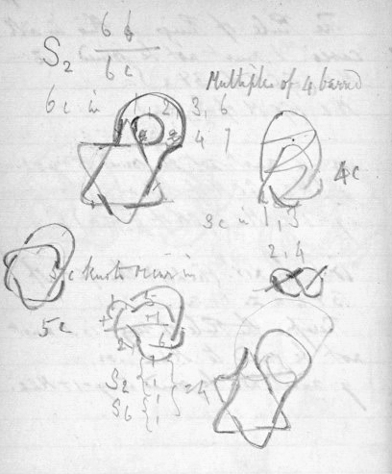

S2 6b/6c Multiples of 4 barred 6c in 1, 2, 3, 6, 5 4 7 4c 3c in 1, 3 2, 4 5c knots [running?] 5c 1, 3- + 7 2,0 6, S2 {1/1}[parenthesis extends to next line] S6 {1/1}[continuation of parenthesis from line above] = 4

p093
If 1 must not be joined to M_{2z}, 1 must not be joined to an even no.
It may be joined to an odd no. Where z = 1. The number of odd nos to which it may be joined therefore are (2b/2 - 1) where b = no of bights, or (x/2 - 1), x being the top left hand number as on p1.
T S₂ 5b/5c x = 10 x/2 - 1 = 4 but there are only 2 knots (? for each 5c form in each series) S₂ 6b/6c x = 12 x/2 - 1 = 5 but there are only 4 knots [But here Z=2]
S₂ 7b/7c x = 14 x/2-1= 6 & there are 8 knots
p094 blank
p095
Experiments in Twisting. z cords are arranged on the circumference of a circular tube at equal distances from one another, thus: - [
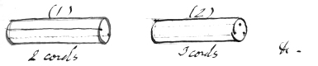
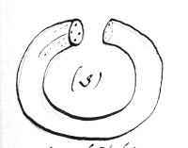
If the tube is now simply bent so that the ends are joined, as is being done in fig 3, the ends of each cord will meet, and separate unlinked circles of cord will result. But if the end of the tube is twisted through 360°/z (where z = no of cords) this will no longer be the case, & other results will follow which it is proposed to investigate. 360°/z is called "an arc", whatever the value

p096 blank
p097
of z, since z being given, the precise value of the arc can always be determined if it is of any importance.
For illustration
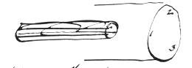
if the tube is here bent & one end twisted through one arc 1 will join 3, 3 join 2, & 2 join 1 & z will be reduced from 3 to 1. Twisted through two arcs 1 will join 2, 3 join 1, 2 join 3, & z again is reduced from 3 to 1. But if it is twisted through 3 arcs (= z arcs = 360°) 1 joins 1, 2 joins 2, 3 joins 3, & z remains 3.
It is of no importance that, twisted the other way, 1 would join 2, 2 join 3 etc since the reverse will be formed & in any case the same pairs join.
p098
K32a/4c 2 arcs 3 cords. Result.
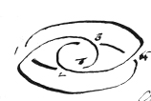
4 Crossings, not alternate, & reducible to the overhand S2 3b/3c
Crossings over 2 & under 2.

Note: A strip of paper given 2 half twists & cut along 2 lines (forming 3 bands) gives 3 linked rings not S2 3b/3c. This is because in twisting flat paper the central 1/3 part longitudinally must always join itself. (But in any Sn where n is even the expected result ought to occur? or might sometimes)
p099
2 cords
Revolved?] through Result.
arcs
1 S2 1b/1c ✓; tested .& with paper strip
2 S2 2b/2c ✓;
3 S2 3b/3c ✓paper strip✓[ bracketed from 1 to 6: everything regular. ]
4 S2 4b/4c ✓;
5 S2 5b/5c ✓; tested with paper strip ✓;
6
3 cords.
arcs. result. z
1 S3 1b/2c ✓; circle 1
+2 S2 3b/3c ✓✓✓ overhand 1
3 3 circles 3
4 anomalous. p 101. z=1.
5
6
p100
K3 3a/6c 3 arcs 3 cords: result.
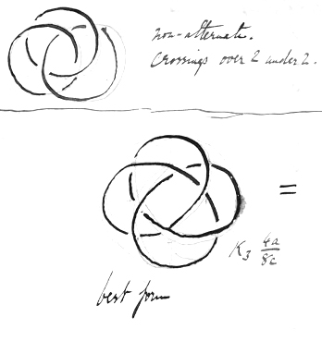

[Caption: non-alternate. crossings over 2 under 2.]
[Caption: =]
[Caption: K3 6a/8c]
best form

p101
K₃ 4a/8c
4 arcs, 3 cords : result
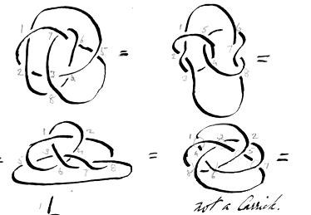

not a Carrick.

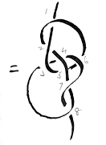

This knot is undoubtedly the result, having been tried many times, and appears to be an irregular irreducible knot of 8 crossings. There are non−alternative crossings.

p102

p103
K₃ 5a/10c
5 arcs 3 cords.
Crossings not alternate
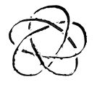
p104

p105
K₃ 6a/12c
6 arcs 3 cords. Result z = 3
[Caption: non−alternate.]
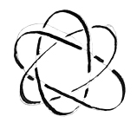
p106

p107
K₃ 7a/14c
7 arcs 3 cords − [Caption: Drawn from rule.]
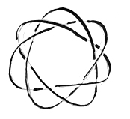
p108

p109
K₃ 8a/16c
8 arcs 3 cords [Caption: rule.]
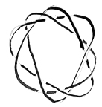
p110

p111
K₃ 9a/18c
9 arcs 3 cords
[Caption: Drawn from rule]
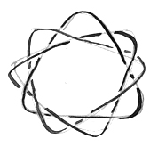
p112

p113
K₃ 10a/20c
10 arcs 3 cords
p114

p115
K₃ 11a/22c
11 arcs 3cords
p116

p117
K₃ 12a/24c
12 arcs 3 cords
p118

p119
K₄ 1a/3c
1 arc 4 cords a twist.
p120

p121
121
K₄ 2a/6c
2 arcs 4 cords
[Caption: Drawn from rule.]
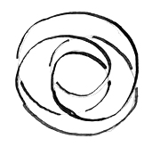
p122
Tested.
K2 1a/c = K1 2a/c
K3 2a/4c = K2 3a/3c
K4 3a/9c = K3 4a/8c
K5 4a/16c = K4 5a/15c
Does K_{n} (n-1)a/c = K_{(n-1)} na/c? Yes.
If so K₅ 4a/16c = K₄ 5a/15c Yes. ✓
(Note that the crossings are 1 less & the arcs 1 more.) & that the reducible knots have 2a/2zc
{Does K_{n} (n-2)a/c = K_{(n-2)} (n+1)a/c? No.
{If so K₄ 2a/c = K₂ 5a/c. No.
p123
K₄ 3a/9c 3 arcs 4 cords
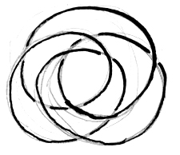
Drawn from rule.
K₄ 3a/9c reduces to, by experiment
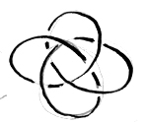
= K₃ 4a/8c.

Full formula: K_{n} (n-1)a/(n-1)²c = K_{(n-1)} na/[(n-1)²-1]c

p124
This series may be expressed, instead of e.g. S₃ 4b/8c as K₃ 4a/8c = 3 cords, revolved through 4 arcs, give a knot of the form S₃ 4b/8c with 8 crossings in alternate sequences of (3-1) = 2 (q. v. p 101 α) z in the result being the same in both series.
p125
4 arcs 4 cords
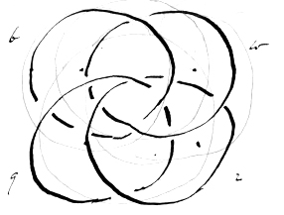
Crossings not alternate but over 3 & under 3.

Rule of Twists.
If in the Plait series we read arc for bight, & no. of original cords for series number then for n cords & x arcs we shall get a form similar to S_{n} (x – b)/c, c being the same BUT, instead of being alternate they are in alternate sequences of (n-1) over & (n-1) under. Z is also the same in the result.
p126
K₄ 5a/c
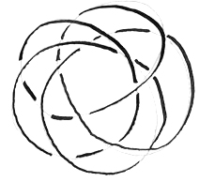
rule.

Does this = K₅ 4a/c? Yes. ✓

p127
5 arcs 4 cords
p128 blank
p129
6 arcs 4 cords 7 arcs 4 cords
p130 blank

p131
8 arcs 4 cords 9 arcs 4 cords
p132 blank

p133
133 10 arcs 4 cords 11 arcs 4 cords 12 arcs 4 cords.
p134 blank

p135
135
K₅ 1a/c K₅ 2a/c
p136 K₅ 4a/c (rule) Does this = K₄ 5a/c ? Yes ✓
p137
K₅ 3a/c K₅ 4a/c
p138 blank
p139
General Principles.
(1) A regular knot is a knot expressed in one of the figures of which the character is shown in vol ii. ad fin. (2) Every complication can be expressed as a regular knot but in this form it may or may not show its least no. of crossings.
(3) Every group (G) of regular knots e.g. Plaits (P) and Torsions (K) has alternate equal sequences of crossings over & under.
(4) The sequence defines the group & must be a (& may be any) measure of (n − 1) from n − (n − 1) [=1] to n − 1. Thus the seq. in P is 1 or n − (n − 1); in K it is (n − 1). These two groups represent the two extremes. Between them lie :-
p140
Groups will be in Series with n = 1 M xy etc?
p141
n − (n − 2) = 2: n − (n − 3) = 3 & so on up to n − 1.
Therefore any measure of (n − 1) may be a sequence number, and form a Group, but only those values of n will supply figures, in which the sequence no. selected is a measure of (n − 1). Thus the P group with seq. of 1 will embrace every figure; so will the K group with seq. (n − 1) for both these seq. nos. are measures of (n − 1). But a group "II" with seq. 2 will only embrace the series in which n is odd (since then (n − 1) is divisible by 2. Group III will embrace only S₄, S₇, S₁₀ & so on; Group IV will be in S₅, S₉ & so on. And in some cases the groups or series of different groups will coincide. Thus
p142
1 = n − (n − 1)
n/n (n – 1)/(n – 1)
n − 1 = n − (n + 1) = (n² – n)/n = n – (n/n)
= (n² − 2n + 1)/(n – 1) = (n − 1)²/(n – 1)
Seq. = n − (n +/− 1) covers K & P
n
3 − 1 = II
4 − 2 = III
5 odd n 5 − 3 = IV
6 − 4 = II ( [ ? ] )
3 − 1 = II
5 − 3 = II
4 − 3 = I
p143
"I" appears in S₂ with a sequence n − (n − 1) = P₁, or with a seq. (n − 1) = K₁ for both are equal to 1. In S₃ (factors of n – 1 = 1, 2,) we have "I"(P) & "II" coinciding with K(n - 1). and no others.
Thus
Series no (n) (n − 1) Factors Sequences
1 0 0 0

2 1 = (n − 1) 1 I (P.K.)

3} 2 1 I (P)
4} 2 = (n − 1) I (K.)

4} 3 1 I (P)
} 3 = (n − 1) III (K.)

5} 4 1 I(P)
} 2 II
4 IV (K.)
6} 5 1 I (P)
} 5 V (K.)

7} 6 1 I (P)
} 2 [circled] II
} 3 [circled] III
} 6 VI (K.)
p144
Parallel Case would be III10 3B/27C reducing to 1K4 9B/27C & then to less. So I2 1B/1C reducing to I2 1B/1C is also parallel.
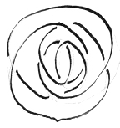
II5 2b/8c(before rings)

reduces to

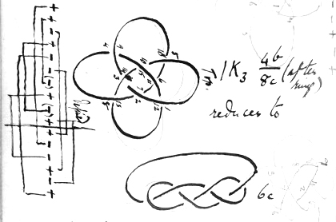

1K3 4b/8c (after rings)

reduces to 6c

which is "A" in Vol ii pp 100-1.

p145
n (n-1) Measures Sequences
8 7 1 I (P)
7 VII (K).
9 8 1 I (P)
2 II
4 IV
8 VIII (K.)
10 9 1 I (P)
3 III 9 IX (K)
and so on.
It seems probable that in every group except I there is a law of reduction for knots before rings. But observe, P always = I, but K=I, II, III, IV ... in succession & the sequences vary. The law of reduction for K is stated in vol vi.
It was found that II₅ 2b/8c reduced to I.K.₃ 4b/8c, & that this reduced to informal knot of 6c, as shown on opposite page.
p146Blank
p147
It is unsafe to deduce a law from this (G K?) because K may be any number, but here we deal with II only, though K also is II; hence what is universal for K ought to be universal for all groups.
On the analogy of the K formula we should have II_{n} xb/x(n-1)c =I.K._{x+1} (n-1)b/x(x-1)c.
Observe, here the reduction is to an I.K, & even that is not ultimate. For x(n-1)c, we may write simply yC as usual. Although it is convenient to have P=Group I, & equally convenient to have K=Groups I, II etc. whenever equal to (n-1) yet it seems probable that one must choose between the

p148
* Fallacy. Because a rule applies to Torsions in every Numeral Group (I,II &c.) it does not therefore apply to every individual of each group. vi.268.
We have IV₅ 2b/8c reducing to I₂ 5a/5b
II₅ 2b/8c reducing to 1K₃ 4b/8c

p149
systems & decide that I shall be single & complete as a Group; II a complete group & so on. In that case K would enter into every group instead of every group entering into K.
Since K enters into every group any rule universal for all Ks is presumably applicable to each & every of I, II, III etc. But it is found that the Law of Reduction needs modification to embrace the case of II₅ 2b/8c reducing to an 1K₃ 4b/8c. According to the K. law it should reduce to S₂ 5b/5c, which it certainly does not, being an irreducible irregular knot of 6z ultimately. Of course the Torsion S₅ 2b/8c is IV₅ 2b/8c & the other is II₅ 2b/8c

p150
Torsion Reduction Formula.
x being less than n
K_{n} xa/x(n-1)c = K_{x} na/n(x-1)c But when this was discovered I regarded the sequence as (n-1) which varies. The
p151
The rules derived from P (in vol ii. ad fin. & summarised in vol iv) apply to all "figures" & index numbers alike: e.g. the relations of b, c, z & x, and the rule of F are the same always. Necessarily, no law of reduction is applicable to P = Group I. A general law of reduction was found for Torsions wherein seq = n-1. A group with seq "n-2" is impossible because n-1 & x-z are primes (unless n=3 & then we get back to I again.) With 5, n – 3 = 2, n – 1 = 4 So here a Group with seq. n - 3 is possible. But in no other possible case can n - 3 be a measure of n - 1 (barring 4, & here we get back to I.) With 7, n - 4 is a factor of n - 1 (3 & 6) but in no other case.

p152 blank

p153
Hence proceeding on these lines does not seem profitable. In whatever series a Numeral Group first appears - & then only - it coincides with K_{x} K itself coincides with P in S_{z}, or rather, both K & P coincide with I in S_{z}.
Hence K & P being understood, it is only interesting to study a Numerical Group from its second appearance onwards
C is always a multiple of Group No (N.)
n is 1+ a multiple of Group No.
n=1+M N (N=Gp. No).
∴ I₁ is incorrect.
It should be O₁ & this defines the circle. So S₁, P₁, etc are incorrect. In every case O₁
p154
[vertical: Not Torsions]
II₅ 1b/4c reduces to O₁ ?/? ( a circle)
II₅ 4b/16c irreducible =
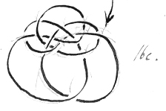
16c.

II₃ 1B/2C reduces by rule to O₁ 3B/0C
II₃ 2B/4C " " I₂ 3B/3C
II₃ 3B/6C in rings. By rule = II₃ 3B/6C
I₂ 3B/3C by rule goes to II₃ 2B/4C
So the Torsion works correctly for torsion both ways. It is a General Law thus:-
N_{(N+1)} xB/xNC = (X-1)_{x} (N+1)B/(n+1)(x-1)C
N = a Numeral Group
p155
Summary of Reduction Data.
III₄ 2B/6C reduced to I₂ 4B/4C
Torsions IV₅ 3B/12C “ “ II₃ 5B/10C
III₄ 3B/9c “ “ II₃ 4B/8C
IV₅ 4D/16C “ “ III₄ 5B/15C
Observe B+C is the same in reduction as in original.
But (Not Torsion)
II₅ 2B/8C “ “ (I.K.)₃ 4B/8C
III₂ 6b/6c “ “ I₂ 2b/2c
Torsion IV₅ 2B/8C ” “ T₂ 5B/5C
Non Torsion
II₅ 3B/12C irreducible. It may be shown thus
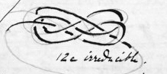
But this conforms to the formula
p156
(1 + MN −1)_{(1 + MN)} ^{(y/(1 + MN −1)) B} /_{(1 + MN) C}
= (^{(y}/_{(1 + MN −1))} − 1) _{(y/(1 + MN −1))} ^{(1 + MN B)/}_{1 + MN (y/1 + MN −1)C}
∴ (MN)_{1+MN} ^{y/MN B}/_{1+ MN C}
= (y/MN −1)_{y/MN} ^{1+MNB}/_{1+MN(y/MN − 1)C}
& then is true only of Torsions N_{(1 + N)}
y/N − 1 + y − N
x = y/n − 1
y = x(n − 1)]
or, in terms of n & y, thus( (n − 1)_{x} ^{y/(n – 1) B}/_{yC} = (y/(n – 1) − 1)_{y/(n – 1)} ^{nB}/_{n(y/(n − 1) − 1)C}
useful where y/(n – 1) ( = x) < n,
or y < x(n − 1) = n² – n
p157
In every group I, II, III etc. alike, where y is less than n, − as it is in the 1b knots − the complication reduces to O1 & is a circle. Thus II₅ ^{1b}/_{4c}, though not a Torsion does so, and I₃ ^{1b}/_{2c}, not a Torsion, does so. With torsions it follows under the N(N + 1) rule; the fact that with other groups x(d[?]) also gives the new n, points to some still more general law.
The Torsion Rule may be expressed thus:-
(n − 1)_{n} ^{xB}/_{yC} = (x − 1)_{x} ^{nB}/_{n(x − 1) C}
or
N_{(N + 1)} ^{xB}/_{xNC} = (x − 1)_{x} ^{(N + 1)B}_{/(N + 1)(x − 1)C}
or
K_{n} ^{xB}/_{x(n − 1)C} = K_{x} ^{nB}/_{n(x − 1)C}
where N = Numeral Group I, II etc., and K = Torsion Group.
p158 blank
p159
Note: Since there are a certain number of irregular knots of 6c, and since all these can be expressed in regular forms in some series of some group, either (1) there must be a law of reduction indicating their alternate irreducible crossings in regular or irregular form −−or−−if there is no such law, the forms break down so far as efficiency in indicating the number e.g. of 6c knots is concerned. It is clear that there may be a law of reduction which does not give the ultimate crossings, as is shown by
II₅ ^{2b}/_{8c} reducing to 1K₃ ^{4b}/_{8c} & then to 1K6c., but observe that this is not a reduction from form to form, but from form to 1K form (1K₃ ^{4b}/_{8c}). It is clear that my forms do not admit the possibility of showing
p160
II₅ ^{4b}/_{8c} ante p 144, reducing to 6c is a good case to work on –
p161
6c on 1z, since values of n with 6c are augmented 1, 2, 3 & 6, viz. 2, 3, 4, 7.
Of these S₂ ^{6b}/_{8c} is on 2z, S₃ ^{3b}/_{6c} is on 3z, S₄ ^{2b}/_{6c} is on 2z, and S₇ ^{1b}/_{6c} on 1z is a "twist".
Therefore the point to which attention should be directed is:− to discover an indication from a knot in regular form of the minimum no. of crossings it might have in an irregular form. And I think it may further be assumed that where a form before rings reduces to a form in an earlier series after rings, the crossings as reduced are irreducible. At any rate the Torsions go to prove this.
p162
Let y = 12
II₇ ^{y/(3 x II)}/_{(y/6 x 6c)} = II₆ ^{2B}/_{10c}
Here M is a measure of y but not of N.
Does II₇ ^{2B}/_{10c} reduce as per formula?
II₇ ^{(12/(3 x II)) B}/_{y 12/((3 x II)) x 6C} = (⁽¹²/_{(3 x 2) – 1)12/(3 x2)} ^{1+(3 x 2)B}_{/(12/(3 x 2) − 1)(1 + 3 x 2)C}
II₇ ^{2B}/_{12C} = I₂ ^{7B}/_{7C}
According to the formula this reduction should take place, the imported multiple 3 being a factor of y (12) but not of II.
﻿p163

? N_{x} ^{(y/N B)}/_{yC} = (y/N − 1)_{y/N} ^{1 + NB}/_{(y/N − 1)(1 + N)C}
II₅ ^{1b}/_{4c} will not go into that form.
Try putting MN with M as 2 − a measure of N & y for N after 1st time.
Then II₅ (⁴/_{2 x 2})^{B}/_{4c} = (4/(2 x 2) − 1)_{4/(2x2)} (1 + (2 x 2))B/(⁴/_{(2 x 2)} − 1)(1 + (2 x 2))C
= O₁ ^{5B}/_{(O x 5)C}
= O₁ ^{5B}/_{O C} which is correct.
May we therefore accept the formula with substitution of MN for N after the group no has been defined? M being a factor of N?−− of y ? −− of both> y is always a multiple of N. Therefore factors of y are factors of N.
p164
^{15b}/_{15(4−1)C}

II₃ , ^{15b}/_{45C}

N_{n} ^{(y/N) B}/_{yC}

II₃ , ^{45/}/_{45C}
p165
Required: a Torsion reduction where a factor of N is not a factor of y.
But that is impossible, N being a factor of y
Required: a case where a factor of y is not a factor of N.
IV₅ 3B/12C reduces to II₃ 5B/10C
Here 3 is a factor of y & not of IV.
May the multiple then be any factor of y?
Bottom left to top right p 168 I.
IV₅ 3B/12C = IV₅ (12/1 x IV)/12
The multiple here is unity. y & N.
II₅ 1B/4C = II₅ (4/2 x II)/4
Multiple here is 2 y & N.
p166
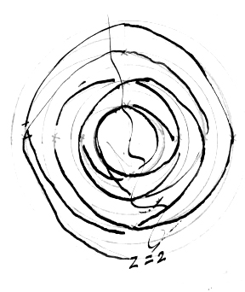
p167
167 II₇ 2B/12C Diagonal writing p 168 T.
Z=GCM of n & y/(n – 1)
12 & 2 = Z
Sequence no N is always a measure of (n−1)
y is always a multiple of n − 1
∴ N is always a measure of C & n − 1 x may be any no.
Can x be a number divisible by a
measure of y not a measure of N₀
x(n − 1) M(n − 1)
Let n=3
[line] x [times] 4 [line] M x 4
Let x be 5 & 5 x 2
Can x be divisible by M(n − 1)
Let x be 12 3(3 − 1)=6
N₃ 12/24 II₃ 12/24 Z=3
p168
M qua factor of y = y/D where D is any divisor of y
y/MN = y/(yN/D) = D/N = x (Sx hypothesis)
∴ when x = D/N , N = D/x, D = Nx & but II₅ 4b/15c
∴ where y is divisible by Nx it should suffice
But II₅ 4b/16c is irreducible though Nx = 8 & y=16
∴ it is not true that M may be any factor of y.
And II₅ 4b/16c also has in for x 16/(2 x 2) where 2 is a factor of II.
∴ it is not true that it may be of N.

S₇ 1b/6c 2b/12c 3b/18c 4b/24c 5b/30c 6b/36c 7b/42c
II₇ 3b/18c = II₇ (18/(3 x 2)) b/18c
Here 3 is the multiple, a factor of y & not of II
z = GCM of 3 & 7. None
∴ z = 1.
Required therefore II₇ 3b/18c
p169
✓n is 1 + MN✓
n−1 is a multiple of N.
✓ N is a measure of (n−1)
✓n−1 is a measure of y
✓ y is a multiple of (n−1)
✓x is a measure of y
✓ y is a multiple of x
✓ y is a multiple of N.
✓ N is a measure of y
✓ y = x(n−1) ✓ x = y/(n – 1) [n = (y+x)/x xn = y+x xn − x = y]
✓ z is G.C.M of x & n
✓ x is any no from 1 to infinity, but only certain values obtain in each S according to values of n.
Can x be divisible by a factor of y which is not a factor of N?
y = x x (n−1)
GCM of x & n = z.
Let z = 1. Then x & n are primes to one another
* Can y/(n − 1) = y / MN where M is not a factor of N.? III₇ −−−−
See p 168 I
p170
[pencil]
Further there are at least 4 other 6c knots which must be reductions from some regular forms, probably with a great number of crossings, though they can be shown in
1K₃ 5b/10c & 1K₄ 5B/15C
p171 171
II₇ 3b/18c should reduce to
II₇ (18/3 x IIb)/18c should reduce to II₃ 7b/14c
if in the formula on 163 MN may be substituted for N where M is any measure of y whether a measure of N or not.
(Observe here N happens to remain the same. See p 168. T.
There remain these disquieting unexplained facts: Whereas Torsion Knots before rings can be reduced, and whereas II₅ 3B/12C, & II₅ 4B/16C are irreducible, not being Torsion Knots.
YET, II₅ 2B/8C can be reduced to an irregular knot of 6c, and can be shown in figure I.K.₃ 4B/8C.
∴ There are 1 or more non−torsions before rings − & perhaps after − which do not show their minimum no. of crossings in their normal figure, & no rule can be found.
p172
p173
Analyse II₅ 2B/8C
What are the necessary relations?
What are the peculiar ones?
Necessary relations:- With n = 5 & B = 2, C must be 8
With n = 5 & C = 8, B must be 2.
With C = 8 & B = 2, n must be 5?
Unnecessary relations
N might be I, II or IV, with n=5
n might be 3 or any higher odd no with N = 2. but B or C could be varied.
Hence we might have
z = 1 I₅ 2B/8C − a plait [irreducible]
z = 1 II₅ 2B/8C the knot in question
z = 1 IV₅ 2B/8C, a torsion reduces
or IIp3, *4b/8c, II₇ 2B/*12C, II₉ *1B/8C
a torsion examines a "twist."
z = 1 z = 1 z = 1
irreducible ??? reduces to 0
p174
p175
Miscellaneous Data.
6c Knots.
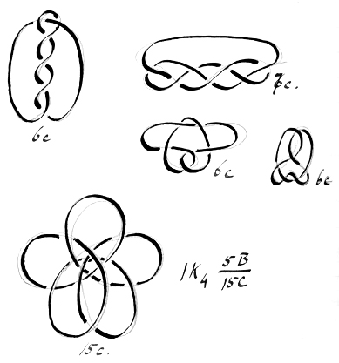
IK₄ 5B/15C 15c.
6c. Timber Hitch
p176
p177
6c Knots continued.
6c. 10c IK₃ 5B/10C 11
6c. [pencil note]Overhand, 1 bight twisted & turned down cf p 267. T.
6c. Weaver.
p178
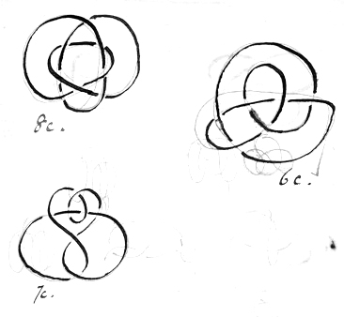

p179
6c Knots continued. 179.
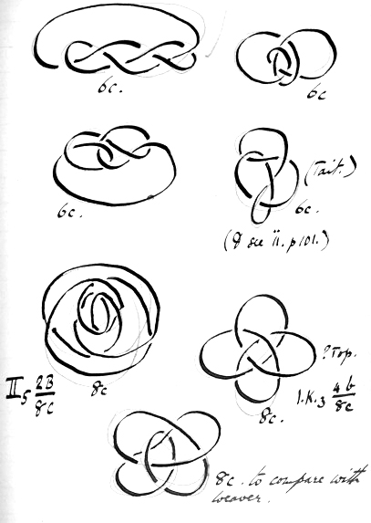

6c. 6c 6c. (Tait.) 6c. (& see ii. p.101)
II₅ 2B/8C 8c
?Top. I.K.₃ 4b/8c 8c.
8c. to compare with weaver
"A" (ii. 100−101.)

p180

p181
6c knots continued
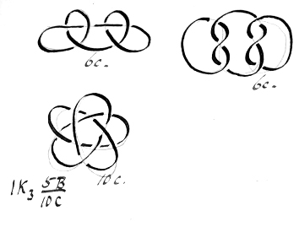
p182
p183
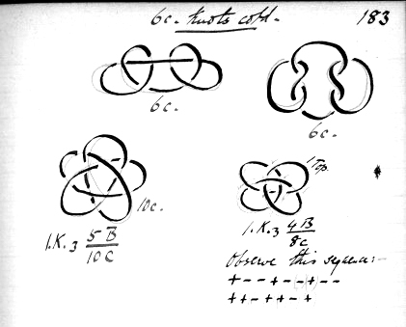

Reef

p184 blank
p185 blank
p186
[pencil] Excluding reverses, there are 2^{(y−1)} possibilities

p187
see 1X.244.
Possibilities
Crossings may be represented as + for over & − for under.
With y crossings there are 2^{y} possibilities. Thus with knot of 2 crossings there are 2² possibilities; with 3 = y, 2³; with 4 = y, 2⁴; & so on, and this is true of every S_{n}.
Tables may be written out, e.g.
y = 2 y = 3
++ +++
+− ++−
−+ +−+
−− +−−
−++
−+−
−−+
It will be observed in these tables, that taken in downward columns in col i, the first half are + &
the second half −; in col ii the first quarter are + & every succeeding alternate quarter are −; in col iii, alternate eighths are +
﻿p188 blank
p189
and −. And every table should be so arranged. If now the horizontal lines indicating the possibilities are numbered, 1, 2, 3 &c. a reference such as "no 3, y=3" indicates a certain order of crossings which can be written down without the aid of the table, for:−
y=3, ∴ Possibilities = 2³ = 8.
“no 3” is in 1st ½ of 8: 1st sign = +
“ 2nd ½ up to? ½ : 2nd sign = −
“ 1st ½ of above: 3rd sign = +
∴ no 3 = + − +.
Observe a 1st, 3rd, 5th fraction of 2^{y} give + signs; 2nd, 4th, 6th &c. give −.
Conversely: Given + − − + + −:
Required table no. Here y = 6. So possibilities = 2⁶ = 64. Table no is 1st ½ of 64, 2nd ½ of this, 2nd ½ of this &c. &c.
p190 blank
p191
thus
+ indicates 1st ½ of 64 = 1 to 32
− − 2nd ½ of 32 = 17 to 32
− − 2nd ½ of 17 to 32 = 25 to 32
+ − 1st ½ of 25 to 32 = 25 to 28
+ − 1st ½ of 25 to 28 = 25 to 26
− − 2nd ½ of 25 to 26 = 26 = Ans.

Powers of 2.
2¹ = 2 1 + 2¹ + 2³ = 11
2² = 4 1 + 2¹ + 2³ + 2⁵ = 43
2³ = 8 1 + 2¹ + 2³ + 2⁵ + 2⁷ = 171
2⁴ = 16 1 + 2¹ + 2³ + 2⁵ + 2⁷ + 2⁹ = 683
2⁵ = 32
2⁶ = 64 2¹ + 2² = 6
2⁷ = 128 2¹ + 2² + 2⁴ = 22
2⁸ = 256 2¹ + 2² + 2⁴ + 2⁶ = 86
2⁹ = 512 2¹ + 2² + 2⁴ + 2⁶ + 2⁸ = 342
2¹⁰ = 1024 2¹ + 2² + 2⁴ + 2⁶ + 2⁸ + 2¹⁰ = 1336
p192

p193
Possibility Tables.

For y = 2, y = 3 see supr. p. 187.
y = 4.

1 + + + +
2 + + + −
3 + + − +
4 + + _ −
5 + − + +
6 + − + −
7 + − − +
8 + − − −
9 − + + +
10 − + + −
11 − + − +
12 − + − −
13 − − + +
14 − − + −
15 − − − +
16 − − − −

p194
p195
y = 5.

1 + + + + +
2 + + + + −
3 + + + − +
4 + + + _ −
5 + + − + +
6 + + − + −
7 + + − − +
8 + + − − −
9 + − + + +
10 + − + + −
11 + − + − +
12 + − + − −
13 + − − + +
14 + − − + −
15 + − − − +
16 + − − − −

17 − + + + +
18 − + + + −
19 − + + − +
20 − + + − −
21 − + − + +
22 − + − + −
23 − + − − +
24 − + − − −
25 − − + + +
26 − − + + −
27 − − + − +
28 − − + − −
29 − − − + +
30 − − − + −
31 − − − − +
32 − − − − −

p196 blank

p197 & p199
y = 6
1 + + + + + +
2 + + + + + −
3 + + + + − +
4 + + + + _ −
5 + + + − + +
6 + + + − + −
7 + + + − − +
8 + + + − − −
9 + + − + + +
10 + + − + + −
11 + + − + − +
12 + + − + − −
13 + + − − + +
14 + + − − + −
15 + + − − − +
16 + + − − − −

17 + − + + + +
18 + − + + + −
19 + − + + − +
20 + − + + − −
21 + − + − + +
22 + − + − + −
23 + − + − − +
24 + − + − − −
25 + − − + + +
26 + − − + + −
27 + − − + − +
28 + − − + − −
29 + − − − + +
30 + − − − + −
31 + − − − − +
32 + − − − − −

33 − + + + + +
34 − + + + + −
35 − + + + − +
36 − + + + − −
37 − + + − + +
38 − + + − + −
39 − + + − − +
40 − + + − − −
41 − + − + + +
42 − + − + + −
43 − + − + − +
44 − + − + − −
45 − + − − + +
46 − + − − + −
47 − + − − − +
48 − + − − − −
49 − − + + + +
50 − − + + + −
51 − − + + − +
52 − − + + − −
53 − − + − + +
54 − − + − + −
55 − − + − − +
56 − − + − − −
57 − − − + + +
58 − − − + + −
59 − − − + − +
60 − − − + − −
61 − − − − + +
62 − − − − + −
63 − − − − − +
64 − − − − − −
p198 blank
p199 see above
p200 blank
p201
201 Notes on the Tables.
(1) The second half of each table shows nothing but reverses of the first half. Hence a – in the first place indicates a reverse.
(2) A knot's no. being given, the reverse no. is (Possibilities) – (knot no.) + 1
Thus in y = 3, the reverse of no 4 is 8 – 4 + 1 = 5.
Given the reverse no., that knot no is (Possibilities) – (reverse no) + 1,
e.g. 8 – 5 + 1 = 4, in the same example.
(3) Alternate crossings appear
(i) when y is odd against No 1+2¹+2³+2⁵..... to 2^{y–2}.,
(ii) when y is even, against No 2 + 2² + 2⁴ + 2⁶....2^{y–2}.
Thus y = 5. y – 2 = 3. 1 + 2¹ + 2³ = 11. And these we find + – + – +.
Again y = 4. y – 2 = 2. 2 + 2² = 6. And no 6 is + – + –.
p202

p203
203
(4) The reverse alternate crossing no in any table is the alternate crossing knot no. in the next higher table.
Thus y=3. Alternate crossing no = No 3. Reverse = 8 – 3 + 1 = 6.
And 6 is the alternate crossing knot no in y = 4 table.
6. I₂ ^{3B}/_{3C} first appears as No 3, y = 3.
It is also (reversed) No 6 y in 3
But also No 3 y = 5
9 y = 5
12 y = 5
15 y = 5
[pencil: Every 3rd no in y = 5 (p195) considered as belonging to S₂]
It is probably No 3 y = 7.
So I₂ ^{5B}/_{5C} first appears as No 11 of y = 5
It is also (reversed) No 22 of y = 5
It is probably No 11 of y = 7
No 22 of y = 7
No 33 of y = 7 & 8 others in y = 7.

p204
1.0₁ 5.0₁
2.0₁ 6.1₂ ^{3B}/_{3C} reverse of 3.
+ 3.1₂ ^{3B}/_{3C} 7.0₁
4.0₁ 8.0₁

p205
205
Illustrations of Tables.
y = 3. (S₂)
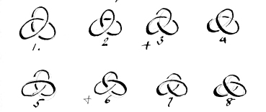
Order displayed = Order of Cutting
y = 3. (S₄.) etc.
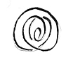
all twists
p206
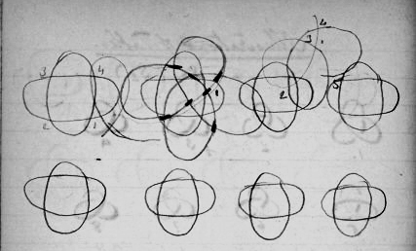
Note order displayed in above, opposite = order of cutting if horizontal oval is made first. If otherwise, then the crossings are merely reversed. So in any case the diagrams may stand.
1 O₁ ^{2B}/_{0C} 5 as 2
2 I² ^{2B}/_{2C} + 6 I₂ ^{4B}/_{4C}
3 do. 7 as 1
4 as 1. 8 as 2
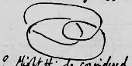
? Might this be considered + + + (–) +
Even if so, it is merely the reverse of + + + + on p.
p207
207
y = 4. (S₂)
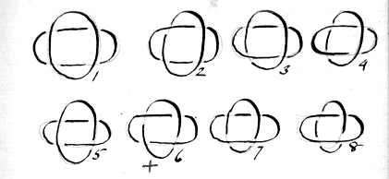
and 8 reverses. Order displayed.
y = 4. (S₃)
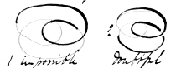
1 impossible doubtful
It is evident at this point that the illustrations should take the order of the defining crossing from the tables. Thus in this from the order is
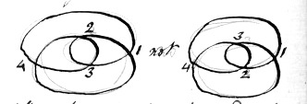
i.e. follow the order of crossing in drawing.

p208
1 0₁ ^{1B}/_{0C} 5 = 1₂ ^{3B}/_{3C}, but it II₃ ^{2b}/_{4C}
2 do. 6 0₁ ^{1B}/_{0C}
+ 3 I₃ ^{2B}/_{4C} 7 0₁ ^{1B}/_{0C}
4 0₁ ^{1B}/_{0C} 8 0₁ ^{1B}/_{0C}
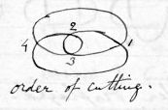
order of cutting.
The method afterwards adopted was to number twice over thus
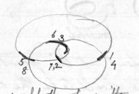
The sequence would then be written
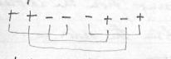
+ + – – – + – + or + + – o – o o o
the o indicating that the crossing had been predetermined e.g. if 1 is +, there is no choice about 4 being – & so on. The knot is really indicated by the sequence + + – o –
p209
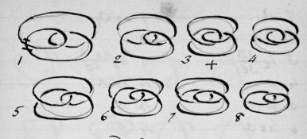209

and 8 reverses
y = 4. (S₅) All twists
The difficulty is this, one would like to use the y = 4 table for 4c in every series, but the 4c not being consecutive, it is unlikely that symmetrical results can be obtained. The y = 5 table would only apply if it was remembered that 1 & 4 must be contrary – these cases would be Tables nos 3, 4, 7, 8, 11, 12, 15, 16 + 8 reverses. In y = 4, table nos. are all applicable, the 4th sign indicating the 5th c
p210
1 0₁ 9 as 3
2 0₁ 10 0₁
3 I₂ ^{3B}/_{3C} 11 I₂ ^{5B}/_{5C}
4 0₁ 12 as 3
5 0₁ 13 0₁
6 as 3 14 0₁
7 0₁ 15 as 3
8 0₁ 16 01
Note 3, 6, 11, 12, & 15 are the only knots showing a sequence of + – + – (or its reverse)
i.e. 4 alternate c on the same pattern circle.

p211
y = 5
(Values of n, 2, 6 of which 6 = Twists)
S₂
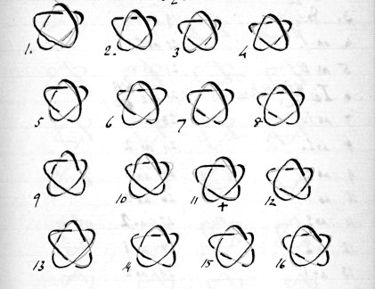
and 16 reverses.
S₆. All twists (32)
Order displayed = Order of Cutting.

p212
1. 0₁ ^{2b}/_{0C}? 17 as 2
2. I₂ ^{2B}/_{2C} 18 as 6 3 x 6
3. do. 19 as 1
4. as 1. 20 as 2
5 as 2 21 as 6
6 I₂ ^{4B}/_{4C} 22 I₂ ^{6B}/_{6C}
7 as 1. 23 as 6
8 as 2. 24 as 2
9 as 2. 25 as 1
10 as 1. 26 as 2
11 as 2 27 as 2
12 as 2 28 as 1
13 as 1 29 as 2
14 as 2 30 as 6. 5 x 6
15 as 2 31 as 1
16 as 1 32 as 2

Note: the series 1, 4, 7, 10 etc are all the same knot until 22, which is the type knot; then 25, 28 etc. are as before–

p213
y = 6.
Values of n, 2, 3, 4, 7 (twists.)
y=6. S₂
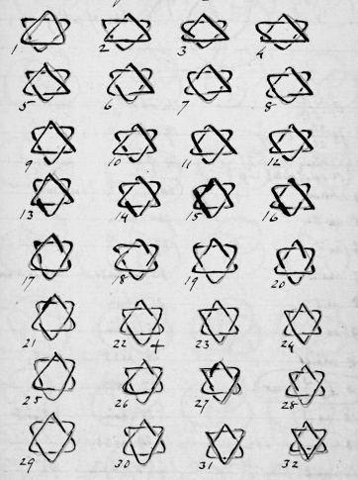
and 32 reverses
Order displayed = Order of Cutting.

p214
abc acb bca bac cab cba
1, 2, 3, 4, 5, 0, 7 defines the knot.
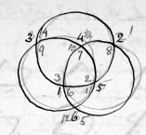

order of cutting.

1–8 7–10
2–11 [8–1]
3–6 [9–4]
4–9 [10–7]
5–12 [11–2]
[6–3] [12–5]

✓ 1 0₁ ^{3B}/_{0C} ✓ 17 as 2
✓ 2 I₂ ^{2B}/_{2C} + 0₁ ^{1B}/_{0C} ✓ 18 chain
✓ 3 On string would = no 2 ✓ 19 chain
On equal metal rings?
✓ 4 chain 20 II₃ ^{3B}/_{6C} (Torsion.)
✓ 5 as 2 ✓ 21 chain
✓ 6 as 1 ✓ 22 as 2
✓7 chain 23: each has 2+, 2– formed chain not as 3 nor 20.
✓ 8 as 2 ✓ 24 chain
✓ 9 as 2 ✓ 25 chain
✓ 10 chain 26 as 23 cf II₃
+ 11 I₃ ^{3B}/_{6C} ([reo.?]) ✓ 27 as 3
✓ 12 as 3 ✓ 28 chain.
✓ 13 chain 29 as 23.
✓ 14 as 2 ✓ 30 chain
✓ 15 as 2 ✓ 31 chain
✓ 16 as 1 ✓ 32 as 2

11 = 6c
20 = 6c
23, 26, 29 = 6c 5 kinds of knot & 32 reverses

Summary 1, 6, 16, = 0_{c}
2, 3, 5, 8, 9, 12, 14, 15, 17, 22, 27 32 = 2c
4, 7, 10, 13, 18, 19, 21, 24, 25, 28, 30, 31, = 6c chain
p215
2⁶ = 64
y=6. S₃.
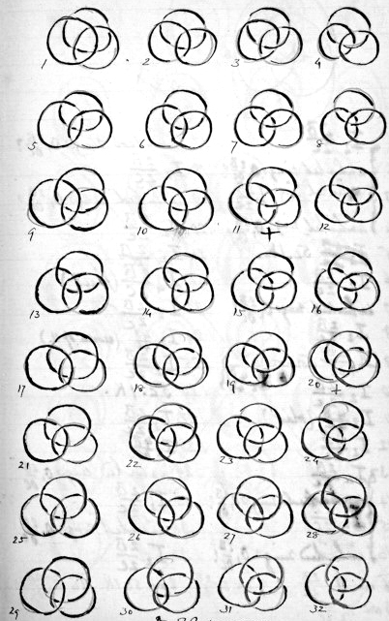
& 32 reverses.
p216
Order of cutting
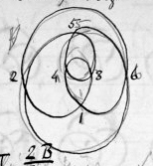
[diagram, ink over pencil with numbered crossings] [right of diagram on diagonal] p 221 [rest of page crossed out with 2 diagonal lines forming large "X"][2 columns each with vertically numbered rows] [large "}" –scribbled out– to right of numbers 1–4, between the numbers and their relevant notes] ✓ 1 I2 2B/2C ✓ 17 unlinked rings 01 2B/0C? ✓ 2 unlinked rings 01 2B/0C? ✓ 18 I2 2B/2C ✓ 3 unlinked rings. I2 2B/2C ✓ 19 unlinked rings 01 2B/0C? ✓ 4 unlinked rings 01 2B/0C ✓ 20 I2 2B/2C [cross] 5 [pencil circle round formulae] I2 2B/2C 5c.IK. ✓ 21 I2 2B/2C ✓ 6 I2 2B/2C [pencil] ["?] ? [redraft?] ✓ 22 [pencil circle to end of ")"]I4 2B/6C (plait) [pencil] Fig of 8 ✓ 7 unlimited rings 01 2B/0C? ✓ 23 I2 2B/2C ✓ 8 I2 2B/2C [pencil] rings ✓ 24 I2 4B/4C (reverse of 11.) ✓ 9 III4 2B/6C (torsion.) red [superscript]le["}" to right of 2 lines] ✓ 25 I2 2B/2C to [I?]2 4b/4C✓ ✓ 10 I2 2B/2C ✓ 26 5c. IK. ✓ 11 I2 4B/4C (plait) ✓ 27 I2 2B/2C ✓ 12 I2 2B/2C [pencil] rings ✓ 28 I2 4B/4C [numbers 13–16 linked by large, scribbled out "}" between number and formulae] ✓ 13 I2 2B/2C ✓ 29 unlinked rings 01 2B/0C ✓ 14 unlinked rings 01 2B/0C? ✓ 30 I2 2B/2C ✓ 15 I2 2B/2C ✓ 31 unlinked rings. 01 2B/0C ✓ 16 unlinked rings 01 2B/0C? ✓ 32 I2 2B/2C 16 are I2 2B/2C 9 are 01 2B/0C 2 are 5c IK. 1 is III4 2B/6C (K.) 3 are I2 4B/4C

p217
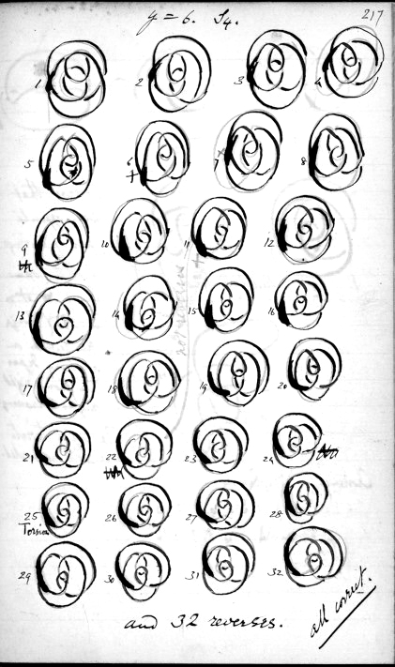
y=6. S₄.
and 32 reverses.
all correct.
p218
12.
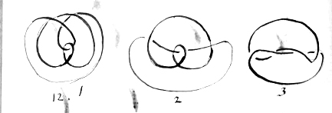
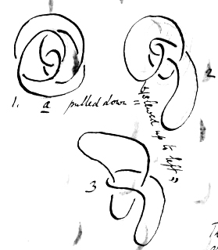

a pulled down = b slewed up to left

Observe that every opposite pair of crossings is the same lay. (Though this requires an arbitrary departure from right angles in crossing!) The inner twists are both unguarded.

p219
No 26. IK. ^{B}/_{5C}. z=2. 5c
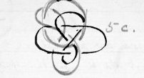
No 5. same as No 26.
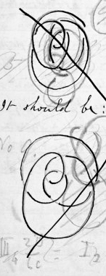
rest of page crossed out with large "X"] [
7 as drawn = 23 really Sign is + + + – – +[below signs] ✓^✓✓✓ wrong 2nd sign is wrong. It should be:– No 9. It then becomes linked rings as before – Probably others are wrongly drawn too, as the orig. 7 does not coincide with anything. Examine this. III₄ ^{2B}/_{6C} = I₂ ^{4B}/_{4C}

p220
Trick: If 2 cords were first tied as 11 & given to someone to separate, it would be impossible. If then tied as 12, the method would appear to be the same, but they would come apart.
1 2 3 4 5 6
21 order of cutting + – + – + + In order of cutting,
reverse = 4 4? signs 2–6 are reversed.
order displayed – – + – + +
12 order of cutting + + – + – – In order displayed, signs
reverse = 5 3?
" displayed + – – + + – 1, 3, 4, 6 are reversed
12 & 21. The reason these are called "curious" is that on inspection it appears incredible that they should be unlimited. Further, they break a sequence of 16, 8, 4, 2, 1, 1 & it becomes 2, 1, 1, 16, 10, 3 (with T reduced)
Anomalous:–
35 12 + 23 instead of 12 + 21 = 33
31 10 + 21 " " 10 + 23 " "
35 8 + 27 " " 8 + 25 " "
1&1, 6, 25 " " 6 + 27 " "
31
p221
y = 6. S₄. Diagrams.
1 0₁ ^{2B}/_{0C} 17 as 2
2 I₂ ^{2B}/_{2C} 18 as 1
3 as 1 19 as 2
4 as 2 20 as 1
5 as 2 21 5c IK(p 219.) as 10
6 I₄ ^{2B}/_{6C} 22 as 2
7 as 2 23 as 1 (curious)
8 I₂ ^{4B}/_{4C} 24 as 2
9 as 2 25 III₄ ^{2B}/_{6C} (Torsion.) = I₂ ^{4B}/_{4C}
10 5c IK (p219) 28 as 2
11 as 2 21 as 8
12 as 1 (curious) 28 as 2
13 as 1 29 as 2
14 as 2 30 as 1
15 as 1 31 as 2
16 as 2 32 as 1
Summary:–
16 of I₂ ^{2B}/_{2C}, viz 2, 31 – 4, 29 – 5,–28 – 7, 26 – 9, 24 – 11, 22 – 14, 19 – 16, 17 (which pairs make 33.)
10 of 0₁ ^{2B}/_{0C}, viz 1, 32 – 3, 30 – 13, 20 – 15, 18 (making 33) and the curious pair 12, 23 (making 35).
2 of I₂ ^{4B}/_{4C} viz 8, 27 (making 35. Note 25 reduces to the same)
2 of IK. 5c. viz 10, 21 (making 31)
1 of I₄ ^{2B}/_{6C}, viz 6
1 of III₄ ^{2B}/_{6C}, viz 25.
p222

Examination of certain knots in F₃ ^{4b}/_{8c}.
Table nos. taken in order of cutting, then first sign being of the travelling line, & so of all the rest.
Table no: 4
22 8 r.c. I₃ ^{4b}/_{8c}
73 (184) 5 r.c I₂ ^{5b}/_{5c} = 184.
74 (183) 5 5c T.H.
75 (182) 5 5c. T.H.
77 (180) 8 r.c. II₃ ^{4b}/_{8c}
81 3 overhand
82 (175) 6 "A"
83 6 Reef (composite.)
84 8 ⊃ vol7. p49.
85 5 5c. T.H.

p223

p224
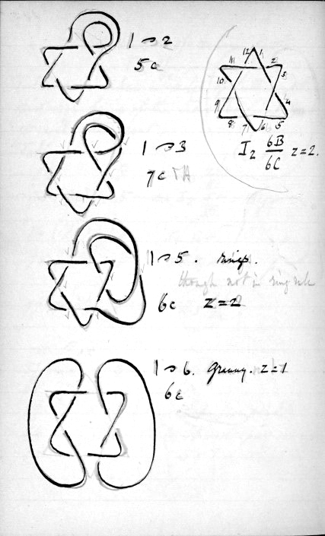

1 ⊃ 2
5c

I₂ ^{6B}/_{6C} z=2.

1 ⊃ 3
7c

1 ⊃ 5 rings

6c z = 2

1⊃ 6 Granny. z = 1
6c

p225
225
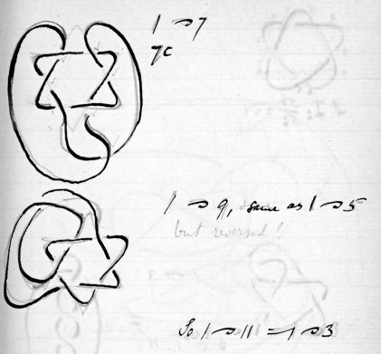
1 ⊃ 7
7c

1 ⊃ 9, same as 1 ⊃ 5
but reversed?

S₀ 1 ⊃ 11 = 1 – 3

Rings are given by M2z = 4, 8, 12 & by 1 ⊃ 5 = 2z + 1, (z=2.)

p226
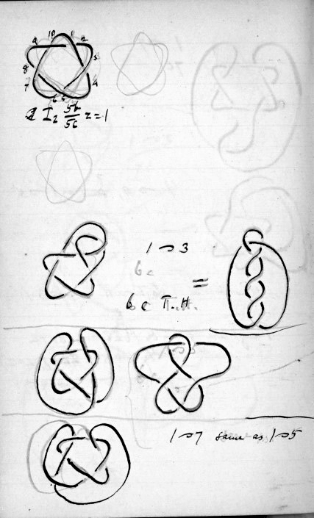
I₂ ^{5b}/_{5c} z=1
1 ⊃ 3 [pencil] 6c = 6c T.H [pencil] T.H.
1 ⊃ 7 same as 1 ⊃ 5

p227
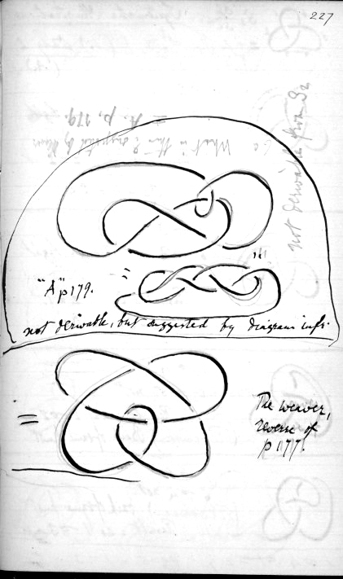
227

6c What is this? Suggested by [Kewer?] not demonstrable from S2
"A" p 179. not derivable, but suggested by diagrams infra
The weaver, reverse of p 177.

p228
Systematic Illustrations (1.) Only 2 (A.)
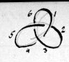
S₂ ^{3b}/_{3c} z=1
should follow next over page

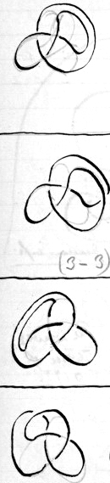
1 ⊃ 2
6 ⊃ 3
not through new bight
Result = I₂ ^{2b}/_{2c} z=2
3c – 1c = 2c
1z + 1z = 2z

1 ⊃ 3
6 ⊃ 4 not through bight.
Result = 0₁ z=1
3c – 3c = 0c
z = z

(3 – 3)c

1 ⊃ 4
6 ⊃ 5 not
Result: as 1 ⊃ 2 supr.
(Reverse) Back of same knot.

1 ⊃ 5
6 ⊃ 4 not
(Reverse) back of same knot
Result = as 1 ⊃ 3 supr

1 ⊃ 4 = 1 ⊃ 2, 1 ⊃ 5 = 1 ⊃ 3

p229
of Cutting & Rejoining.
bights cut. S₂.
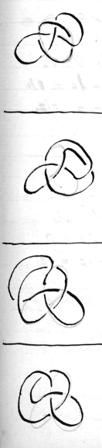
First appearance
Repeated in ^{4b}/_{4c} 1 ⊃5, &c.
^{8b}/_{8c} 1 ⊃ 9 not.
1 ⊃ 2 6 ⊃ 3 through new bight
Result: 1K. 5c. z=2
3c + 2c = 5c 1z + 1z = 2z

1 ⊃ 3 6 ⊃4 through bight
Result I₃ ^{2b}/_{4c} Fig of 8.
= 4c T.H.
3c + 1c = 4c.
z = z

1 ⊃ 4
6 ⊃5 through
Result = 1 ⊃ 2 supr.
(Reverse) back of same knot

1 ⊃ 5
6 ⊃ 4 through
Result = 1 ⊃ 3 supr.
(Reverse). back of same knot.

p230
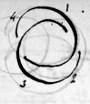
Sz 2b/2c
z = z.
should precede preceding

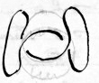
1 ⊃ 2
4 ⊃ 3 not.
Result 01 2c – 1c = 1c
2z – 1z=1z

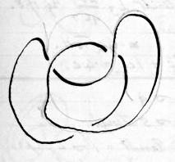

1 ⊃ 3
4 ⊃ 2 not.
Result O₁ 2c – 2c = 0
2z – 1z = 1z
as 1 ⊃ 2 supr.

Not a genuine reverse
1 ⊃ 3 = 1 ⊃ 2

p231

231 First appearance : Repeated in 3b/3c 1 ⊃ 3 etc. & 7b/7c 1 ⊃ 7 not.
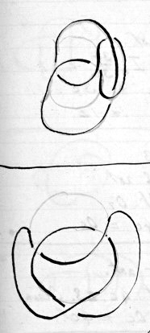
1 ⊃ 2 4 ⊃ 3 Oro.
Result I3 2b/4c Fig. of 8.
=4 c T.H.
2c + 2c = 4c
2z − 1z = 1z

1 ⊃ 3
4 ⊃ 2 Oro.
Result I3 2b/4c. = 4c T.H.
as 1 ⊃ 2 supr.

Ut supra but not really a Reverse.
1 ⊃ 3 = 1 ⊃ 2

p232
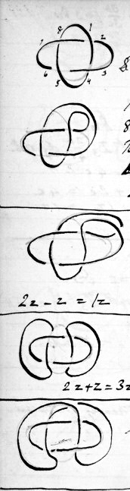

z = 2 − 4c.
I2 4b/4c

1 ⊃ 2 8 ⊃ 3 not.
Result : I2 3b/3c z = 1
4c − 1c = 3c
2z − z = 1z

1 ⊃ 3 8 ⊃ 2 not
Result : 01
2z − z = 1z
4c − 4c = 0c

1 ⊃ 4 8 ⊃ 5 not.
Result : 4c.z3. Chain.
2z + z = 3z.
4c − 0c = 4c.

1 ⊃ 5 8 ⊃ 4 not.
Result 0₁ z = z.
4c − 4c = 0c.
2z − 0z = 2z.

1 ⊃ 6 = 8 ⊃ 3 = 1 ⊃ 2
1 ⊃ 7 = 8 ⊃ 2 = 1 ⊃ 3

p233
233 First appearance : repeated in 5b/5c 1 ⊃ 5 etc. 9b/9c not.

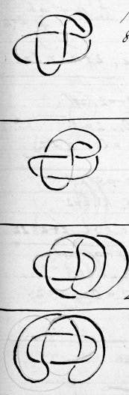
1 ⊃ 2 8 ⊃ 3 etc.
Result. 6c1K. (The Weaver)
4c + 2c = 6c
2z − z = 1z.

1 ⊃ 3 8 ⊃ 2 etc.
Result 5c T.H. 1K.5c.
4c + 1c = 5c.
2z − z = 1z.

1 ⊃ 4 8 ⊃ 5 etc.
Result 6c z = 3. Endless Chain.
2z + z = 3z.
4c + 2c = 6c.

1 ⊃ 5 8 ⊃ 4 etc. Result 1K5c. z. = z. shown in S2 3b/3c with
1 ⊃ 2, 6 ⊃ 3 etc.
4c + 1c = 5c.
2z + 0 = 2z

1 ⊃ 6 = 1 ⊃ 2.
1 ⊃ 7 = 1 ⊃ 3

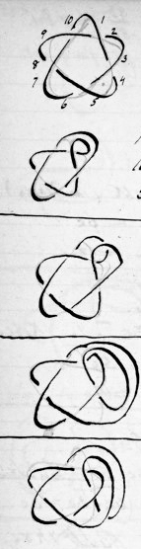
p234
I₂ 5b/5c. z = 1.

1 ⊃ 2. Result I₂ 4b/4c z = 2
10 ⊃ 3 not.
5c − 1c = 4c , z + 1z = 2z.

1 ⊃ 3 , 10 ⊃ 2 not.
Result. O₁. z = 1.
5c − 5c = 0c, z = z
(5 − 4)c

1 ⊃ 4, 10 ⊃ 5 not
Result 5c I.K. z = 2
5c + 0c = 5c, z + z = 2z

1 ⊃ 5, 10 ⊃ 4 not.
Result O₁ . z = 1.
5c − 5c = 0c, z = z.
(5 − 5)c

✓ ⊃
p235
First appearance: Repeated in
6b/6c /⊃5Oro ✓
?10b/10c/⊃ 9 not.
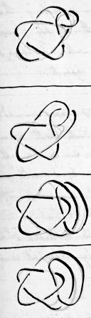
1⊃2, 10 ⊃3Oro.
Result: 7c 1k. 2z.
5c + 2c = 7c. z+z = 2z.

1⊃ 3, 10 ⊃2 Oro.
Result. 6c T. H. (1K.)
5c +1c = 6c, z=z.

1⊃4, 10⊃5 Oro.
Result 7c 1K. z = z. 5c +2c = 7c, z+z = 2z.

1⊃5, 10 ⊃4 not
Result 6c Same as I₂ 4b/4c 1 ⊃ 2 8⊃3Oro. 5c+c = 6c z = z

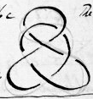
The weaver z=1

1 ⊃ 6 = 10 ⊃ 5 = 1 ⊃ 4
1 ⊃ 7 = 10 ⊃ 4 = 1 ⊃ 5
1 ⊃ 8 = 10 ⊃ 3 = 1 ⊃ 2
1 ⊃ 9 = 10 ⊃ 2 = 1 ⊃ 3

p236
Summary of results to this point.
(1) Repetitions commence when 1 is joined to the next highest even no. exceeding the no. of bights. (Thus with 3b, 1 to 4 repeats, with 4b 1 to 6 repeats: with 5b 1 to 6 repeats ; with 6b, 1 to 8 repeats.)
Not.
(2) 1 ⊃ x - (x-2) = 1 ⊃ 2 gives immediately preceding knot. With both even & odd b. it decreases c. by 1; with odd c it increases z by 1 ; with even c it decreases z by 1. z always = 1 (no good for new knots.) (see p260ff)
(3) 1 ⊃ x - (x - 3) = 1 ⊃ 3 reduces c to 0 & z (if not 1 already, when it remains 1) to 1. (No good for new knots. Not) Not.
(4) 1 ⊃ x-(x-4) = 1 ⊃ 4 leaves c unaltered and adds 1 to z. (New Knot.) (Good.)
(5) 1 ⊃ x - (x-5) = 1 ⊃ 5 reduces c to 0 (or ? 1) & leaves z unaltered. (no good.)

p237
237
(i) Repetitions as in (1)
Also: (This is not so with the "nots".)
1 ⊃ to b (b, c, odd)
1 ⊃ to b+1 (b, c, even) (repeat knots formed from immediately preceding regular knot:) by joining 1 & 2. (At least 1 ⊃ 5 in I₂ 4b/4c & I₂ 5b/5c did: & 1 ⊃ 3 in I₂ 3b/4c
Oro.
(ii) irregular knots (except that I₂ 2b/2c gives I₃ 2b/4c ) c increased by 2 ; with odd c. increased by 1, even c, decreased by 1 as in (2) opposite.
Oro
(iii) All timber hitches, c increased by 1 , z always = 1.
Oro.
(iv) I.Ks. c increased by 2 ; z increased by 1.
[See p 260ff]

p238
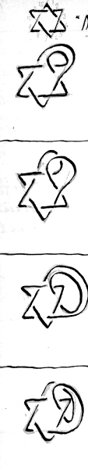
"Not" (1 ⊃ 7 the last)

1 ⊃ 2
12 ⊃ 3 confirms rule z - 1 (6 - 1)C

1 ⊃ 3
12 ⊃ 2 confirms rule
z – 1, 6 - 5C

1 ⊃ 4
12 ⊃ 5 confirms rule
z + 1
c unaltered

gives I₂ 2b/2c
1 ⊃ 5 6c - 4c = 2c
12 ⊃4 z unaltered = 2
The 4th previous knot.
z unaltered (6 - 4) c

p239
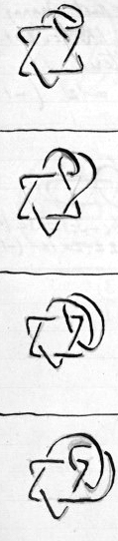
Oro.

6c + 2c = 8c
2z - z = 1z vol7. p47

6c + 1c = 7c
2z - z = 1z
7c Timber Hitch.

6c + 2c = 8c
2z + z = 3z

6c + 1c = 7c

2z =2z

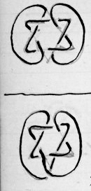
p240
1 ⊃ 6 New knot . granny on
12 ⊃ 7 1z I.K. 6c. z=1.
c unaltered
2z - 1z = 1z (-1)
c unaltered z-1

1 ⊃ 7 (last)
12 ⊃ 6

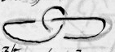
= I₂ 3b/3c 6c - 3c = 3c (-3)
Regular Knot 3 earlier. 2z -z = 1z (-1)
(6 - 3) c
z - 1

p241
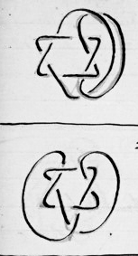
6c + 2c = 8c
2z - 1z = 1z

= 1 ⊃ b+1, c being even
6c + 1c = 7c
2z - 1z = 1z

p242
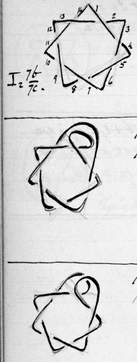
Not.
(1⊃8 last)
I_{z} 7b/7c.

1 ⊃ 2
14 ⊃ 3 confirms rule.
z+1
(7 - 1)c

1 ⊃ 3, 14 ⊃ 2.
confirms rule.
z unaltered (7-5)c

p243

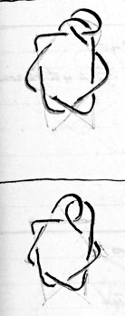
7c + 2c = 9c
1z + 1z = 2z

7c + 1c = 8c
1z = 1z
8c Timber Hitch.

p244
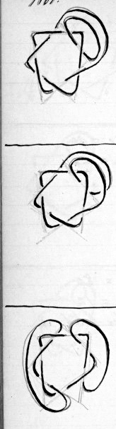
Not.
I_{z} 7b/7c
1 ⊃ 4, 14 ⊃ 5
[14 ⊃ 5]
confirms rule.
z + 1 c unaltered

1 ⊃ 5, 14 ⊃ 4.
gives I_{z} 3b/3c = 4th previous knot.
7c − 4c = 3c.
z unaltered.

1 ⊃ 6, 14 ⊃ 7.
New Knot.
c unaltered
z + z = 2z (+1)

p245
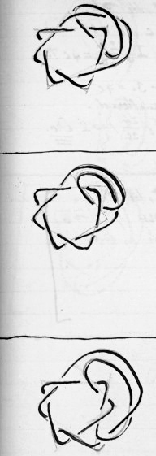
7c + 2c = 9c
1z + 1z = 2z

7c + 1c = 8c
1z = 1z

7c + 2c = 9c
1z + 1z = 2z

p246
Not I_{z} 7b/7c
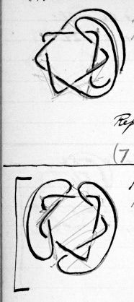

1 ⊃ 7, 14 ⊃ 6.
4c, z = 1
= I₃ 2b/4c = 4c T.H.
7c − 3c = 4c
z unaltered.
Repeats I₂ 2b/2c 1 ⊃ 2 etc.

1 ⊃ 8, 14 ⊃ 9.
reverse of 1 ⊃ 6.

counts as repetition

p247 Oro. 247

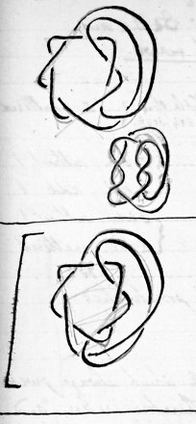
7c + 1c = 8c
1z = 1z

7c + 2c = 9c Repetition (not a reverse) of 1 ⊃ 6

p248
"Not". Iz series.
Amended Laws. (corrected for I₃ also)
(1) z rule: –
1 ⊃ 1, or 1 +{a multiple of 4} ....z unaltered
{e.g. 1x4, 2x4, 3x4 &c.}
1 ⊃ 2, or 2 + M₄..... z =2 or 3, subtract 1
z =1, add 1
1 ⊃ 3, or 3 + M₄...... z =2 or 3, subtract 1
z =1, unaltered
(z always = 1 in Iz )
1 ⊃ 4 or (4+) M₄.........add 1. (z=2 or 3)]
This exhausts all possibilities.

(2) Crossings rule. Ignoring 1 ⊃ 2 which always gives preceding knot & is therefore useless, with even bights (or c) only repetitions of knots will be obtained if 1 ⊃ to a part with a no. higher than (no. of bights) + 1; while with odd bights (or c) any no. higher than (no. of bights) gives repetitions.
[p261. T.]

p249
(1) z rule: – 1 ⊃ 1, or 1+M₄ z unaltered 1 ⊃ 2, or 2+M4 z> 1 : subtract 1 z=1 : add 1. 1 ⊃ 3, or 3+M₄ z>1 : subtract 1 z=1 : unaltered 1 ⊃ 4, or M₄ add 1. This exhausts all possibilities, and covers both I₂ & I₃, "not" etc.
(2) In I₃ repetitions begin
(i) y indivisible by (2^{(n−1)}) 4:} at nos. exceeding y/2
(ii) y divisible by 2^{(n−1)} 4:} at nos. exceeding (y/2 + 1)
In I₂ repetitions begin
(1) y indivisible by 2^{(n−1)} 2: at nos exceeding y
y divisible by 2^{(n−1)}2: at nos exceeding (y + 1)
Divisor appears to be 2^{(n−1)} p251
p250
not see p260 ff.
1 ⊃ to one of these numbers, and continue, diminishing by 1 each time until 1 ⊃ 4, when stop. Thus, given 9c odd. ∴ commence with 1 ⊃ bights, no of : =9
1 ⊃ bights, no of : =9
1 ⊃ −1 =8
1 ⊃ −2 =7
1 ⊃ −3 =6
1 ⊃ −4 =5
1 ⊃ −5 =4
These will be all the knots which need be considered. The no. of crossings will be found from the following table: –

even c 1 ⊃ bights no of, +1 }
odd c 1 ⊃ bights, no of. } subtract 3c

even c 1 ⊃ (−0) }
odd c 1 ⊃ −1 } c unaltered

even c 1 ⊃ −1 }
odd c 1 ⊃ −2 } subtract 4c

even c 1 ⊃ −2 }
odd c 1 ⊃ −3 } c unaltered.

p251
p252
p253
[Oro.?]
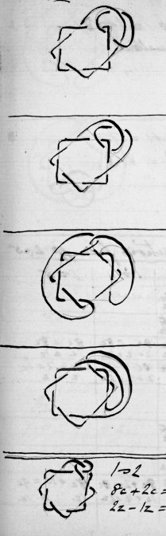
8c + 2c = 10c
2z + 1z = 3z

8c + 1c = 9c
2z = 2z

8c +2c = 10c
2z − 1z = 1z

8c + 1c = 9c
2z − 1z = 1z

1 ⊃ 2 1 ⊃ 3
8c + 2c = 10c 9c T.H.
2z − 1z = 1z 8c + 1c = 9c
2z − 1z = 1z

p254
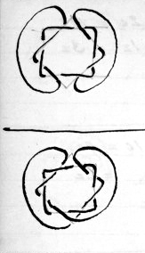
I_{z} 8b/8c
1 ⊃ b = 1 ⊃ 8
c = 8, unaltered
z = 3.

1 ⊃ b + 1 = 1 ⊃ 9
c = 5 = 8 − 3
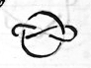
z = 2

Deductions from pp 265
Not. 1 ⊃ 2 1 ⊃ 3 1 ⊃ 4 1 ⊃ 5

I₃ 2b/4c 4c − 2c = 2c 4c − 1c = 3c
1z + 1z = 2z z = z

I₃ 3b/6c 6c − 1c = 5c 6c − 1c = 5c
3z − 1z = 2z 3z − 1z = 2z

I₃ 4b/8c 8c − 1c = 9c 8c − 1c = 7c 8c = 8c 8c = 8c
1z + 1z = 2z 1z = 1z 1z + 1z = 2z 1z = 1z

I₃ 5b/10c 10c − 1c = 9c 10c − 1c = 9c 10c = 10c 10c + 1c = 11c
1z + 1z = 2z 1z = 1z 1z + 1z = 2z 1z − 1z

[Oro.?]
I₃ 2/4 4c + 2c = 6c 4c + 1c = 5c
1z + 1z = 2z z = z

I₃ 3/6 6c + 2c = 8c 6c + 1c = 7c
3z − 1z = 2z 3z − 1z = 2z

I₃ 34/8 8c + 2c = 10c 8c + 1c = 9c 8c + 2c = 10c 8c + 1c = 9c
1z + 1z = 2z 1z = 1z 1z + 1z = 2z 1z = 1z
I₃ 5/10

p255
255
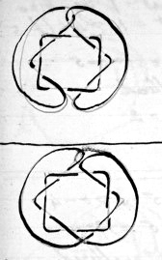
8c + 2c = 10c
2z + 1z = 3z

8c + 1c = 9c
2z = 2z

ff. infer . I₃. only.
Not
1 ⊃ 2 generally c − 1 , z = z
1 ⊃ 3 −− 1c
1 ⊃ 4 −− c = c
1 ⊃ 5 anomalous.
[Oro?]
1 ⊃ 2 +2c z = z.
1 ⊃ 3 +1c
1 ⊃ 4 +2c
1 ⊃ 5 ?
p256
I_{z} 9b/9c z = 1 c odd.
last = 1 ⊃ 9 = b.no
1st = 1 ⊃ 4 = (b − 5)
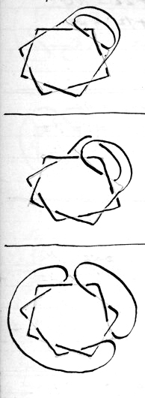
1 ⊃ 4 = 1 ⊃ b − 5
c unaltered
z + 1 = 2

1 ⊃ 5 = 1 ⊃ b − 4
c = 5 = 9 − 4
z = 1, unaltered. gives
Iz 5b/5c

1 ⊃ 6 = 1 ⊃ b − 3
c unaltered
z = 2 = z + 1

p257
257
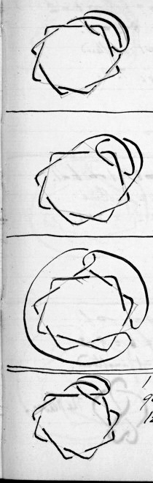
9c + 2c = 11c.
1z + 1z = 2z

9c + 1c = 10c
1z = 1z

9c + 2c = 11c
1z + 1z = 2z

1 ⊃ 2 1 ⊃ 3
9c + 2c = 11c. = 10c T.H.
1z + 1z = 2z

p258
I_{z} 9b/9c
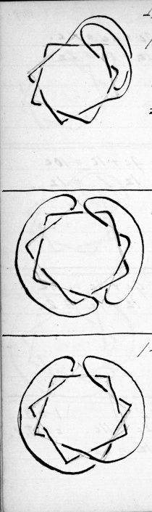
1 ⊃ 7 = 1 ⊃ 6 − 2
c = 8 − 2 = 6.
z= 1 unaltered
= 6c T.H.

1 ⊃ 8 = 1 ⊃ b − 1
c = unaltered
z = 2 = z+1

1 ⊃ 9 = 1 ⊃ b.
c = 6 = 9 − 3
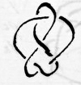
z = 1 unaltered.

The Weaver.

p259
259
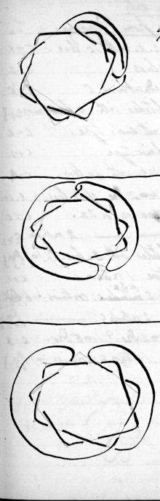
9c + 1c = 10c
1z = 1z

9c + 2c =11c
1z +1z = 2z

9c + 1c = 10c
1z = 1z

p260
260
S₂ only
Deductions from Preceding. I₂
1 ⊃ 2 not : repeats regular knot with 1c less. c − 1.
1 ⊃ 2 [Oro?] : weaver class c + 2
1 ⊃ 3 not : twists reducible to 0 c − c
1 ⊃ 3 [Oro?] : timber hitches with 1 c more. c + 1}
1 ⊃ 4 not : chains with ends type. c = c
1 ⊃ 4 [Oro?] : endless chain type. c + 2
1 ⊃ 5 not : repeats regular knot with 4c less. c − 4
1 ⊃ 5 [Oro?] : repeats to 2 [Oro.?] of 1c less. regular knot c + 1
1 ⊃ 6 not : granny type on 1 or 2z. c = c
1 ⊃ 6 [Oro?] : granny type on 2 outside c. c + 2
1 ⊃ 7 not : timber hitches with 3c less. cf 103 [Oro.?] c − 3 }
1 ⊃ 7 [Oro?] : granny type, 1 exterior c. c + 1
1 ⊃ 8 not : granny type 2 or 3z: continues 1 ⊃ 6 [Oro?]. c = c.
1 ⊃ 8 [Oro?] : granny type 2 outside c: continues 1 ⊃ 6 [Oro.?] c + z
1 ⊃ 9 not : repeats 1 ⊃ 2 [Oro?] & 1 ⊃ 5 [Oro?]. c − 3
1 ⊃ 9 [Oro?] : granny type: 1 exterior c: continues 1 ⊃ 7 [Oro?]. c + 1

p261
(I2 only) 261.
I₃ Hence, up to 1 ⊃ 9 consider only: –
c – 1 see I₃ 2b/4c 1 ⊃ 2 [Oro.?]
c + 2 1 ⊃ 3 [Oro.?]
c – 1 1⊃ 4 not
c + 1 Omit 2 & all odd nos., in "not." 1 ⊃ 4 [Oro.?] omit 5 in "[Oro?]."
c = c 1 ⊃ 6 not
c + 2 1 ⊃ 6 [Oro?]
? [see Oro bb?] by 4 = c
_ _ _ _ = c + 1 [circled] 1 ⊃ 7 [Oro]
1 ⊃ 8 not
1 ⊃ 8 [Oro?]
1 ⊃ 9 [Oro?]
Rules: (I2 only)
(1) z rule (p248.1.) stands good for "not" & "[Oro?]"
(2) c remains same 1 ⊃ even no. not.
c + 2 1 ⊃ even no. [Oro.?]
c + 1 1 ⊃ odd no. [Oro.?]
(3) Repetition rule (p248.2.) stands good for not & [Oro?].
(4) Even c, give c knots {c/z of (c + 1) c/2 of (c + 2)[}[Oro?]
some repetitions
even c, give c knots for not but some will be repetitions

p262
I₂ Only
(5) odd c gives (c – 1) knots (c – 1)/2 of (c + 1) & (c – 1)/2 of (c + 2) Oro?
odd c gives (c – 1) knots for not. But some will be repetitions.
(6) Required: knots with y.c. Proceed as follows: –
A. Suppose y is odd. (i) Oro?: – y c can be derived from regular knot (y – 2), & regular knot (y – 1).
(ii) With regular knot (y − 2) join 1 to all even nos.
"[Oro?]" up to & including 1 ⊃ (y – 2). This will give (y – 3)/2 knots of y crossings.
Then with regular knot (y − 1) join 1 Oro to all odd nos. except 5 up to & including 1 ⊃ y. This will give (y – 3)/2 knots.
(iii) With regular knot y join 1 not to all even nos. up to (y – 1) (i.e. y) Excluding 2. This gives (y −3)/2 knots.
B. Suppose y is even. Oro: – y , c can be derived from regular knot (y – 2) & regular knot (y – 1).
(i) With regular knot (y − 2) join 1 to all even nos. Oro. to (y – 2). This gives (y – 2)/2 knots.
p263
I₂ only 263
(ii) Then with regular knot (y – 1) join 1 to all odd Nos. Oro to y – 1 except 5. This gives (y – 4)/2 knots.
(iii) with regular knot y, join 1 to all even nos "not" up to & including y, but excluding 2 & commencing with 1 ⊃ 4. This will give (y – 2)/2 knots different from B.i.
The totals thus obtained therefore are: –
y odd: (y – 3 + y – 3 + y – 3)/2 = 3(y – 3)/2
y even: (y – 2)/2 + (y – 4)/2 + (y – 2)/2 = (3y – 8)/2.
For example: Required irregular knots with 6c.
B. (i) 6 – 2 = 4, 6 – 1 = 5. With 4 join 1 Oro to all even nos. up to 4, viz. 2,4. This gives (6 – 2)/2 = 2. They are the Weaver & Endless chain.
(ii) With 5 join 1 Oro to odd nos. up to 5, excluding 5. viz. 3. This gives (6 – 4)/2 = 1. It is the Timber Hitch.
(iii) With regular knot 6 join 1, not to even nos. up to 6, excluding 2. viz. 4,6. This gives (6 – 2)/2 = 2. They are Ended Chain & 1z Granny.
Total ((6 – 2) + (6 – 4) + (6 – 2))/2 = (18 – 8)/2 = 5.
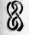
6c 2z. = I₄ ²/₆ reversed. Also Reef, "A", p179.
﻿

p264
264
(I₂ only) Next: Required irregular knots of 5c.
A. (i) 5 – 2 = 3, 5 – 1 = 4
With regular knot 3c, join I Oro to all even nos. up to 5 – 2, i.e. 2 only. The knots given are
(5 – 3)/2 = 1. viz the 5c. 2z irregular knots. (There are 2 such however)
(ii) With regular knot 4c. join1 Oro to all odd nos. up to 4+1 = 5, except 5, viz: 3.
This gives 5 – 3/2 knots = 1 knot. It is the 5c. T.H.
(iii)With regular knot 5 join I not to all even
nos. up to 4 (6) excluding 2. i.e. 1 ⊃ 4.
This gives (5 – 3)/2 knots = 1. It is an ended chain knot.
There are therefore 3(5 – 3)/2 knots = 3.
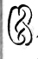
5c irregular knot 2z not yet found.

p265
265
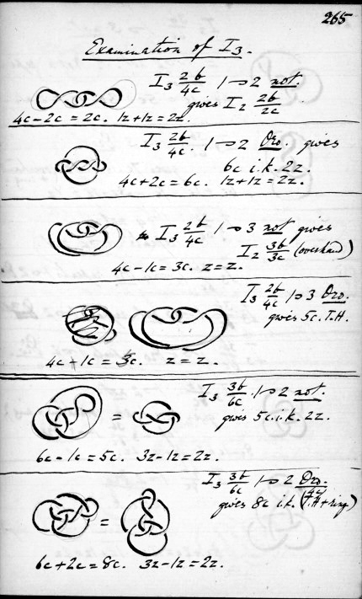
Examination of I₃.

I₃ 2b/4c 1 ⊃ 2 not.
gives I₂ 2b/2c

4c – 2c = 2c. 1z + 1z = 2z.

I₃ 2b/4c. 1 ⊃ 2 Oro. gives
6c irregular knot 2z.
4c + 2c = 6c.
1z + 1z=2z.

I₃ 2b/4c 1 ⊃ 3 not gives
I₂ 3b/3c (overhand)
4c – 1c = 3c. z = z.

I₃ 2b/4c 1 ⊃ 3 Oro.
gives 5c. T.H.

4c + 1c = 5c. z = z.

I₃ 3b/6c. 1 ⊃ 2 not.
gives 5c. irregular knot 2z.
6c – 1c = 5c. 3z – 1z = 2z.

I₃ 3b/6c 1 ⊃ 2 Oro.
gives 8c irregular knot
(4c T.H. + ring)

6c + 2c = 8c. 3z – 1z = 2z.

p266
266.
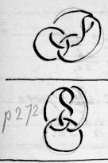
I₃ 3b/6c 1 ⊃ 3 not.
= 1 ⊃ 2 not. ? Nota repetition.
6c – 1c = 5c.
3z – 1z = 2z.

I₃ 3b/6c 1 ⊃ 3 Oro.
gives 7c. irregular knot 2z (overhand
+ ring.)
6c + 1c = 7c.
3z – 1z = 2z

I₃ 3b/6c 1 ⊃ 4 not.
repeats 1 ⊃ 2 not.

I₃ 3b/6c 1 ⊃ 4 Oro repeats 1 ⊃ 2 Oro

I₃ 3b/6c 1 ⊃ 5 not repeats 1 ⊃ 2 not.

I₃ 3b/6c 1 ⊃ 5 Oro repeats 1 ⊃ 2 Oro.

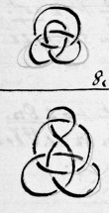
I₃ 4b/8c 1 ⊃ 2 not.
gives 7c. irregular knot 2z. (overhand + ring)
cf I₃ 3b/6c 1 ⊃ 3 Oro.
8c – 1c = 7c. 1z + 1z = 2z.

I₃ 4b/8c 1 ⊃ 2 Oro
10c irregular knot 2z.
(twisted overhand + ring.)
8c + 2c = 10c 1z + 1z = 2z.

p267
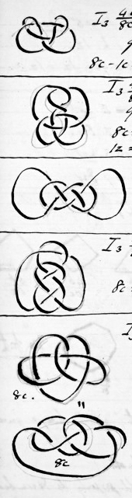
267.
I₃ 4b/8c 1 ⊃ 3 not.
gives 7c irregular knot 1z.
(Once twisted over – hand, bight turned back.)
8c – 1c = 7c. 1z = 1z.

I₃ 4b/8c 1 ⊃ 3 Oro
9c irregular knot 1z. (twice twisted
overhand, bight turned back.)
8c + 1c = 9c
1z = 1z.

I₃ 4b/8c 1 ⊃ 4 not.
8c irregular knot 2z. (common carrick bend.)
8c = 8c. 1z + 1z = 2z.

I₃ 4b/8c 1 ⊃ 4 Oro
10c irregular knot 2z.
8c + 2c = 10c. 1z + 1z = 2z.

I₃ 4b/8c 1 ⊃ 5 not.
8c. irregular knot 1z. (c. not alternate).
(such an 8c knot might be made with alternate c.)
irreducible. = Linked overhands.

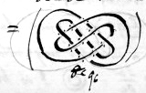
8c = 8c 1z = 1z.

9c

p268
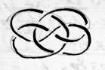
I₃ 4b/8c 1 ⊃ 5 Oro.
9c irregular knot. 1z.
8c + 1c = 9c.
1z = 1z.

1 ⊃ 6 not repeats 1 ⊃ 2 not
1 ⊃ 6 Oro " 1 ⊃ 6 Oro.
1 ⊃ 7 not " 1 ⊃ 3 not
1 ⊃ 7 Oro " 1 ⊃ 7 Oro

Series 01
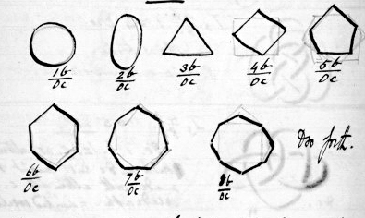
1b/0c
2b/0c
3b/0c4
b/0c
5b/0c

6b/0c
7b/0c
8b/0c
& so forth.

For purposes of new knots, "not" always gives
2 unlinked rings.
But Oro may give knots.
Note: 2 unlinked rings, would properly be described
as O₂ 2b/0c = [2 concentric circles] & so forth.
p269 269
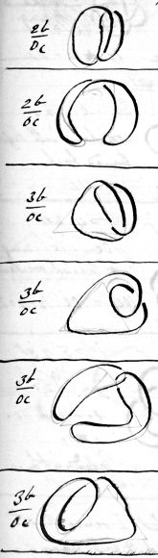
Examination of O1 Oro.
2b/0c 1 ⊃ 2 Oro.
gives I₂ 2b/2c z = z
0 + z = 2c, 1z + 1z = 2z.

2b/0c 1 ⊃ 3 Oro.
gives O₁ 1b/0c
0c = 0c 1z = 1z

3b/0c 1 ⊃ 2 Oro
gives I₂ 2b/2c z = z
0 + z = 2c, z + 1z = 2z

3b/0c 1 ⊃ 3 Oro
gives O₁ 1b/0c
0c = 0c 1z = 1z.

3b/0c 1 ⊃ 4 Oro
gives I₂ 2b/2c
0 + 2c = 2c 1z + 1z = 2z
repeats 1 ⊃ 2 Oro

3b/0c 1 ⊃ 5 Oro
repeats 1 ⊃ 3 Oro.

It is evident at this point that more than
2c can never be obtained.
p270
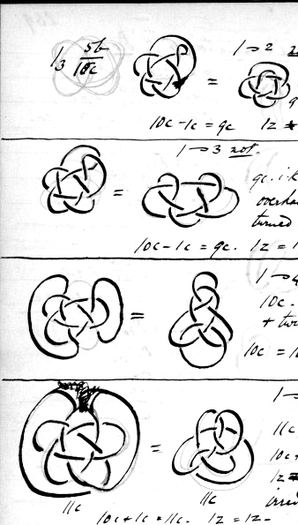

I₃ 5b/10c
= overhand + ring. 1 ⊃ 2 not.
9c
10c – 1c = 9c
1z + 1z = 2z

1 ⊃ 3 not.
9c. irregular knot 1z.
overhand with bight
turned back
10c – 1c = 9c 1z = 1z

1 ⊃ 4 not.
10c. irregular knot
ring + twisted overhand
10c = 10c 1z + 1z = 2z

1 ⊃ 5 not.
11c, 1z.
10c + 1c = 11c.
1z = 1z
irreducible.
10c+1c = 11c. 1z = 1z.

Evidently after this point I series knots
become highly complicated & with many c.

p271
Examination of II.3.

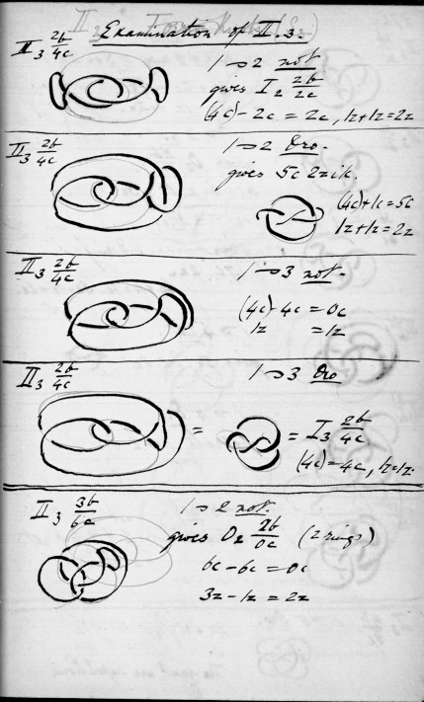
II₃ 2b/4c
1 ⊃ 2 not
gives I₂ 2b/2c
(4c) – 2c = 2c 1z + 1z = 2z

II₃ 2b/4c
1 ⊃ 2 Oro.
gives 5c 2z irregular knot.
(4c) + 1c = 5c
1z + 1z = 2z

II₃ 2b/4c [
1 ⊃ 3 not.
(4c) – 4c = 0c
1z = 1z

II₃ 2b/4c
1 ⊃ 3 Oro
I₃ 2b/4c
(4c) = 4c 1z = 1z.

II₃ 3b/6c
1 ⊃ 2 not.
gives O₂ 2b/0c (2 rings)
6c – 6c = 0c
3z – 1z = 2z

p272 272.
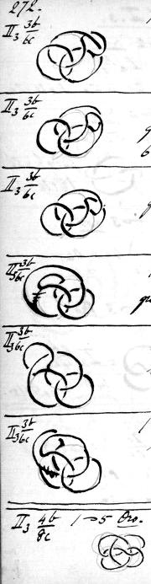
II₃ 3b/6c 1 ⊃ 2 Oro.
4c T.H & rings = 8c. 2z.
6c + 2c = 8c
3z – 1z = 2z

II₃ 3b/6c 1 ⊃ 3 not.
gives O₂ (2)b/0c
6c – 6c = 0c
3z – 1z = 2z

II₃ 3b/6c 1 ⊃ 3 Oro.
gives overhand & ring. p 266
7c, 2z.
6c + 1c = 7c
3z – 1z = 2z

II₃ 3b/6c 1 ⊃ 4 not.
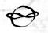
gives 5c. irregular knot. 2z.

II₃ 3b/6c 1 ⊃ 4 Oro
repeats 1 ⊃ 2 Oro.

II33b/6c 1 ⊃ 5 not.
repeats 1 ⊃ 2 not & 1 ⊃ 3 not
O₂ 2b/2c

II₃ 4b/8c 1 ⊃ 5 Oro.
8c + 1c = 9c 1z = 1z.

The rest are repetitions.

p273 273
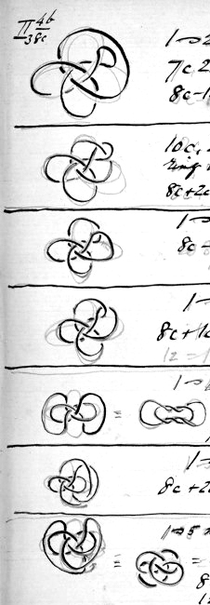
II₃ 4b/8c
1 ⊃ 2 not
7c 2z, overhand & ring
8c – 1c = 7c 1z + 1z = 2z

1 ⊃ 2 Oro
10c, 2z.
ring on twisted overhand.
8c + 2c = 10c 1z + 1z = 2z

1 ⊃ 3 not.
8c – 8c = 0c 1z = 1z

1 ⊃ 3 Oro
8c + 1c = 9c 1z = 1z.

1 ⊃ 4 not
6c Granny on 2z
10c – 4c = 6c 1z + 1z = 2z.

1 ⊃ 4 Oro.
8c + 2c = 10c 1z + 1z = 2z.

1 ⊃ 5 not = overhand
8c – 5c = 3c 1z = 1z

Additional mathematics from volume 6

Groups of Knots.
In Plait Knots the sequence of like crossings (i.e. over or under) is 1, equivalent to saying they are alternate.
In Torsion Knots it is x-1 over x-1 under & so on.
This suggests that knots may be arranged in a number of series according to the sequence of their crossings, thus
n (= an indefinite no, indicating a series.)
Torsions n-1
n-2
n-3
.
.
.
n-(n-2)=2
n-(n-1)=1
n-n=0
Why not also
x+1
x+2
x+3
.
. x+(α-1) = total no of C.

But instead of sequence being (n-2) over, (n-2) under & so forth, they might be (n-2) over, (n-1) under, (n-17) over (n-63) under & so on. The Weaver knot is of such a class.

Summarised
Formulae derived from Plaits etc.
Symbols:
P Plait knot series (formerly S)
n number of parts
B bights
A arcs in torsions
C crossings
F geometrical form (simplest)
r no. of repetitions of F
x coefficient of B
y coefficient of C
N, the numeral defining the group & equal to regular sequence of over, under etc. E.g. I for plaits, II, III & so forth
K any torsion group
S any undefined group
i.k. irregular knot
r.k. regular knot
P_{n} xB//yC, z = F = , defines everything & means a knot in Plait series with
n parts, x bights, y crossings on z separate cords etc.
(1) x = y/(n-1)
(2) y = x(n-1)
(3) y given: find values of n.
Ans: Every measure, augmented by 1, of y from 1 to y inclusive.
[e.g. y = 8: measures are 1, 2, 4, 8
(4) n & x given: find z.
Ans: z = GCM of n & x or, if no GCM, z = 1.
(5) n & y given: find z
Ans: z = GCM of n & y/(n-1) of if no GCM of n & y, z = 1
or, no GCM of n & y/(n-1), z = 1
(6) y given, z = 1: Find values of n.
(i) Set out measures of y from 1 to y inclusive.
(ii) Augment them all by 1
(iii) Strike out augmented measures which are multiples or equals of unaugmented measures greater than 1.
(iv) Remaining augmented measures = values of x.
(6a) y given, z = given no. exceeding 1. Find values of x.
(i) Set out measures of y less than y from 1 onwards inclusive.
(ii) Augment them all by 1.
(iii) Strike out augmented measures indivisible by z.
(iv) Remaining augmented measures = values of n.
(7) P_{n} xB/yC & z given, find F repeated r times. Occurrences of F always = z. Therefore new value of z will be r.
For yC substitute x(n – 1)C (2)
Ans:
zF in P_{n} xB//(x(n – 1)C) becomes rF in P_{(rn/z)} rx/z B//((rx/z)((rn-z)/z)C)
Example: In P₆ 3B/15C, a certain f occurs 3 times and z accordingly = 3.
Required, F repeated twice
P₆ 3B/15C = P₆ 3B/(3(6-1)C)
∴ x = 3, z = 3, n = 6 &r = 2. (=z’, new z).
Knt requires is P_{(2 x 6 / 3)} (2 x 3/3) B//((2 x 3/3)((2 x 6) – 3)/3)C
= P₄ 2B//6C, z = 2
(Figure of 8 F.)

Torsion Rule:-
K_{n} xB/X(n – 1)C = K_{x} nB/n(x – 1)C
or (n – 1)_{n} xB/yC = (x – 1)_{x} nB/n(x – 1)C
or N_{(N + 1)} xB/xNC = (x – 1)_{x} (N + 1)B/(N + 1)(x – 1)C
or (n – 1)_{n} (y/(n – 1))B/yC = ((y/(n – 1))-1)_{y/(n – 1)} nB/n(y/(n – 1))C

Note that in all groups, from 4 independent formulae we get:-
1. x = y/(n- 1)
x is a measure of y
x is any number from 1 onwards satisfying above conditions.
x is a multiple of
x + y = xn
N is a measure of (n – 1) and any measure from 1 to (n – 1) where (n – 1) exceeds 1; aliter (otherwise, Ed) N = n – 1
[In Torsions n = original number of cords = N + 1 & A = B]
n is 1 + a multiple of N
n = (y + x)/x = 1 + y/x
n is a multiple of z
n – 1 is a measure of y
n – 1 is a multiple of N
r = z
y = x(n – 1)
y is a multiple of n – 1
y is a multiple of N
y is a multiple of x
z = r
z is GCM of n & x
z is a measure of n
z is a measure of x

y given, find values of N_{n}
Values of N = measures of y z
Values of x = measures of y each augmented by 1
Values of n as found which may be attached to values of n as found must be each equal to 1 + a multiple of N. Thus, y = 10, find N_{n}
Values of N = measures of y = 1, 2, 5, 10
Values of N = augmented measures of y = 2, 3, 6, 11
(i) N = I
n = 1 + 1 x I = 2
n = 1 + 2 x I = 3
n = 1 + 5 x I = 6
n = 1 + 10 x I = 11
(ii) N = II
n = 1 + 1 x II = 3
n = 1 + 5 x II = 6
(iii) N = V
n = 1 + 1 x V = 6
n = 1 + 2 x V = 11
(iv) N = X
n = 1 + 1 x X = 11
Ans =
I₂ 10B/10C (z = 2) torsion & plait
I₃ 5B/10C (z = 1) plait
I₆ 2B/10C (z = 2) plait
I₁₁ 1B/10C (z = 1) plait twist
II₃ 5B/10C (z = 1) torsion
II₁₁ 1B/10C (z = 1) twist
V₆ 2B/10C (reduces) (z = 2) torsion
V₁₁ 1B/10C (z = 1) twist
X₁₁ 1B/10C (z = 1) torsion, twist
Therefore 4 genuine knots result = (no. of factors of y + 1) subtracted from the total number of nominal knots. ? is there always a reducible knot?
Again y = 6, find N_{n}
Values of N = 1, 2, 3, 6 = N
Augmented 2, 3, 4, 7 =n
(1) N = I
n = 1 + 1 x I = 2
n = 1 + 2 x I = 3
n = 1 + 3 x I = 4
n = 1 + 6 x I = 7
4 genuine knots are
I₂ 6B/6C z = 2
I₃ 3B/6C z = 3
I₄ 2B/6C z = 2
I₂ 3B/6C z = 3

Ans
I₂ 6B/6C, I₃ 3B/6C, I₄ 2B/6C I₇ 1B/6C
II₃ 3B/6C, II₇ 1B/6C,
III₄ 2B/6C,
VI₇ 1B/6c

Torsion Figures

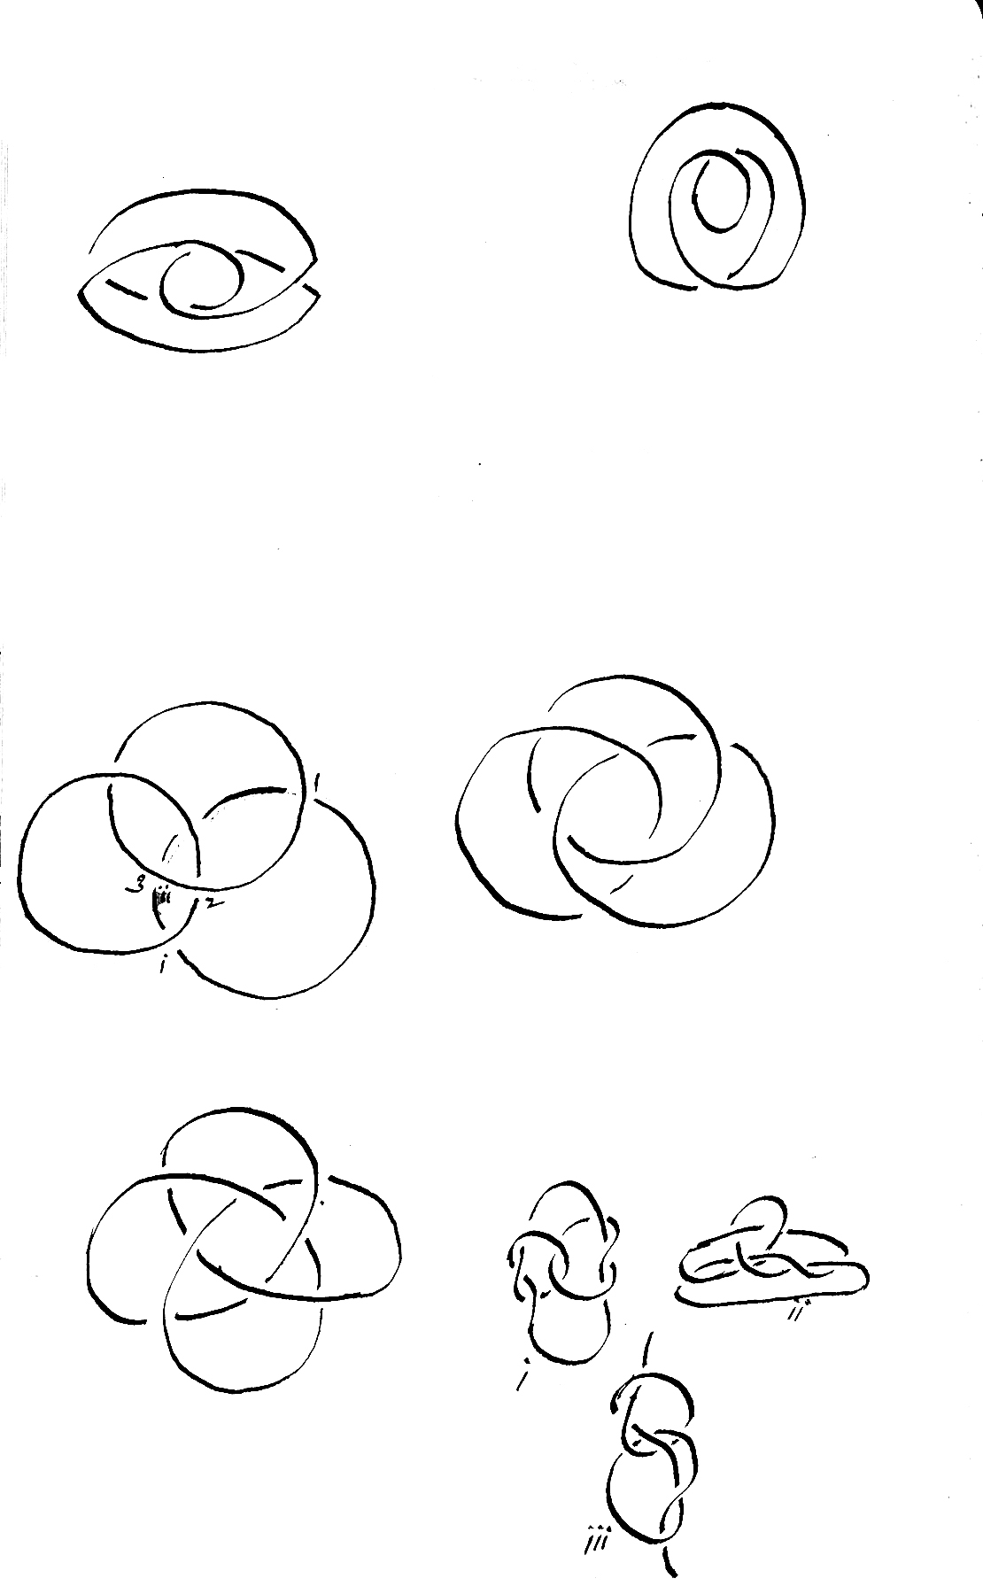
Actually made by twisting K₃ 1a/2C z = 1
K₃ 2a/4C z = 1 II₃ 1B/2C
Reducible to K₂ 3a/3C = overhand
II₃ 2b/4c

Attempt to draw breaks down cf supra III₃ 3B/6C

Made by twisting K₃ 3a/6C z = 3 II₃
3B/6C

II₃ 4B/8C = III₄ 3B/9C other forms

K₃ 4a/8C z = 1 K₄ 3a/9C cf V 258 B

i, ii, iii all show 8 (non-alternate) C

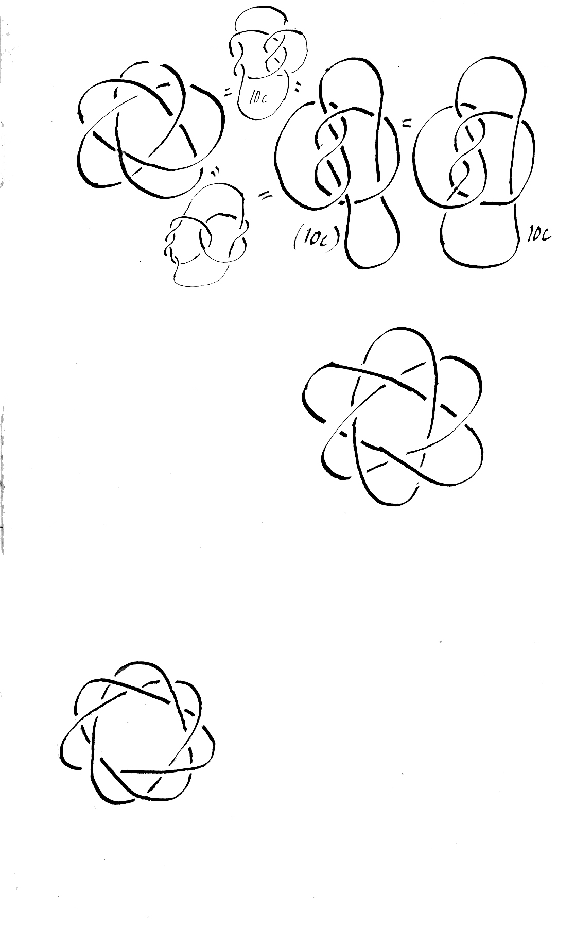

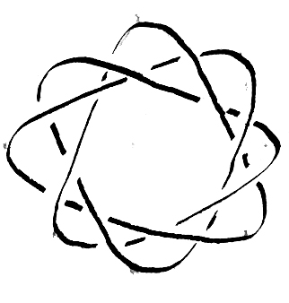

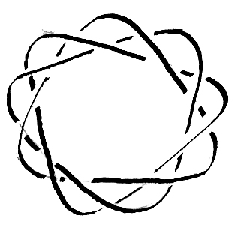

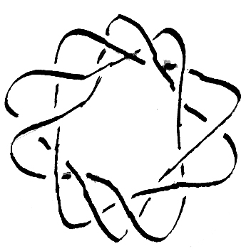

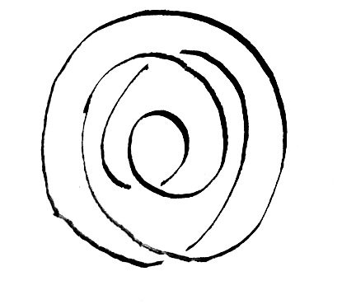

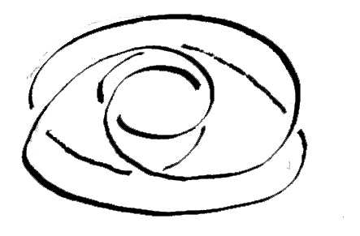

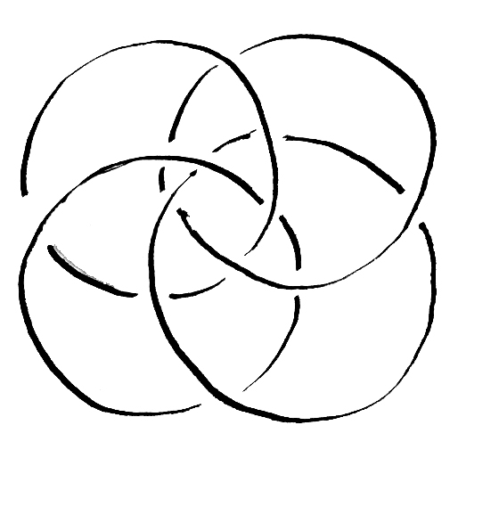

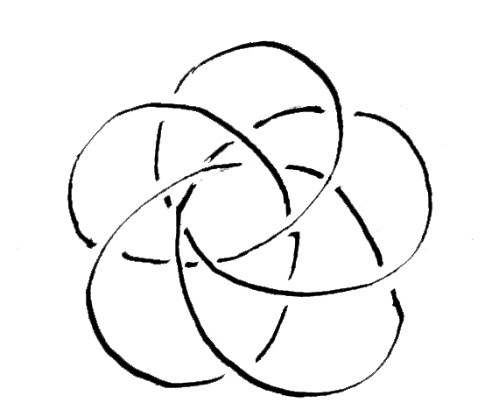

K₄ (6a/18c) z = 2
K₄ (7a/21c) z = 1

K₄ (8a/24c) z = 4
K₄ (9a/27c) z = 1

K₄ (10a/30c) z = 2
K₄ (11a/33c) z = 1

K₄12a⁄36c z=4
K₅1a⁄4c z=1

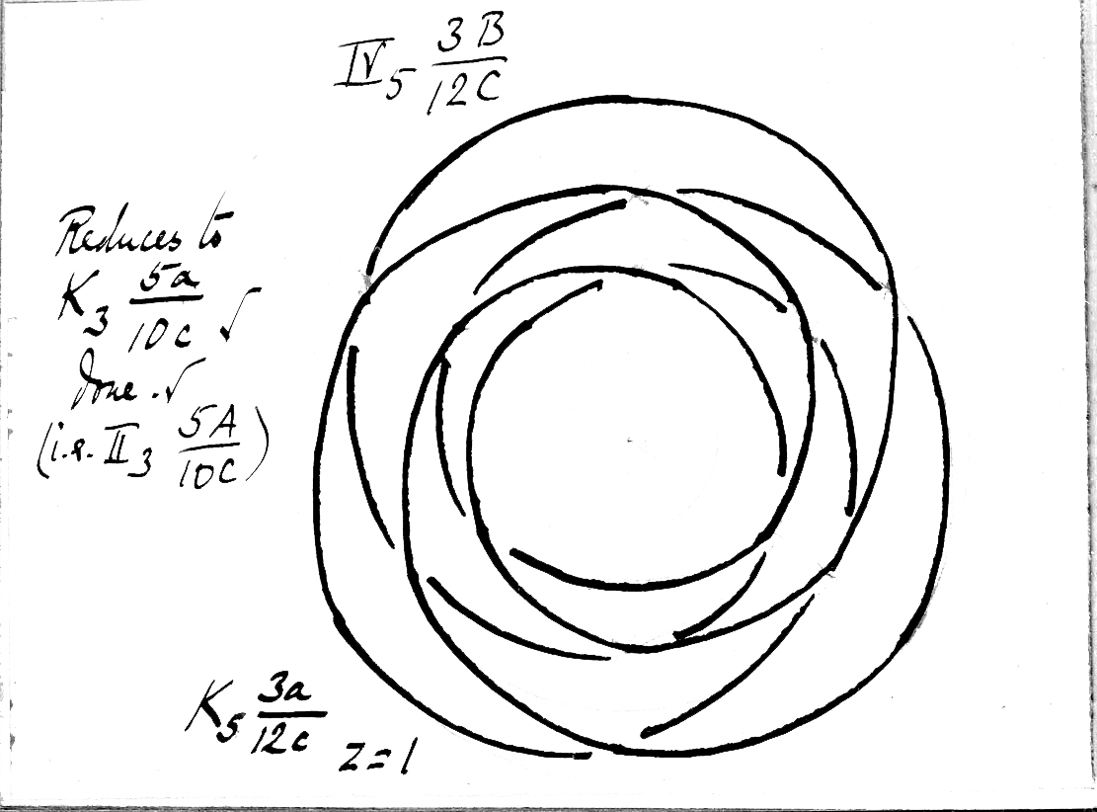
IV₅ 2B/8C
K₅ 2a/8c z = 1
= (by formula) K₂ 5a/5c = I₂ 5B/5C

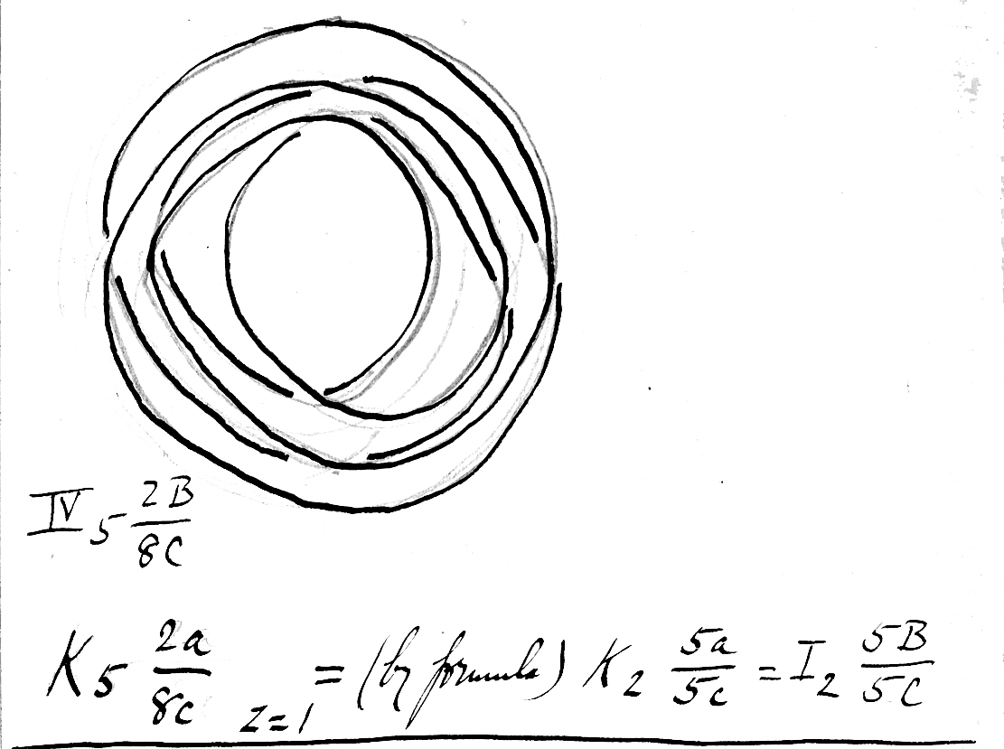
IV₅ 3B/12C
Reduces to K₃ 5a/10c ✓ done. ✓ 
(i.e. II₃ 5A/10C) K₅ 3A/12c z = 1

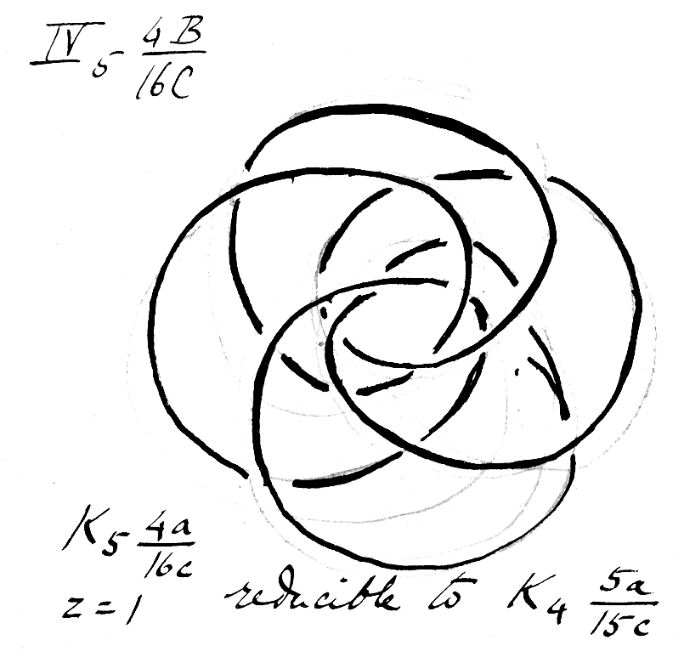
IV₅ 4B/16C (made.) reduced ✓

K₅ (4a/16c) z = 1 reducible to K₄ (5a/15c) K₅ (5a/20c) z = 5

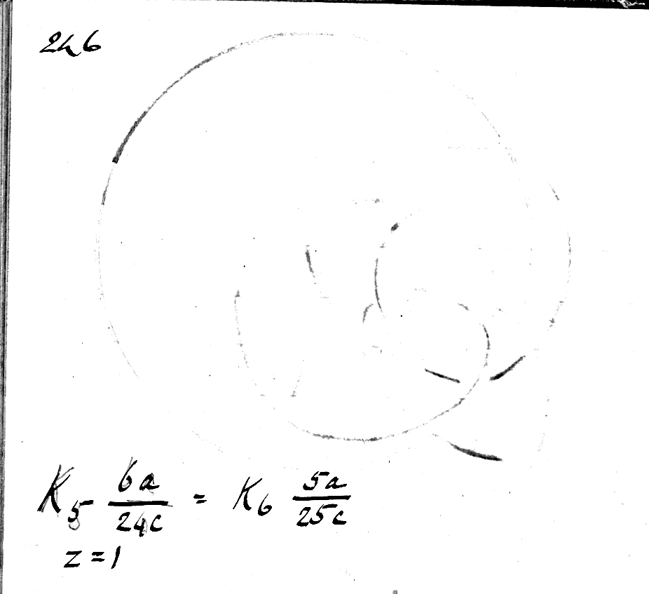

K₅ (6a/24c) = K₆ (5a/25c) z = 1 K₅ (7a/28c) z = 1

K₅ (8a/32c) z = 1 K₅ (9a/36c) z = 1

K₅ (10a/40c) z = 5 K₅11a/44c) z = 1

K₅ (12a/48c) z = 1

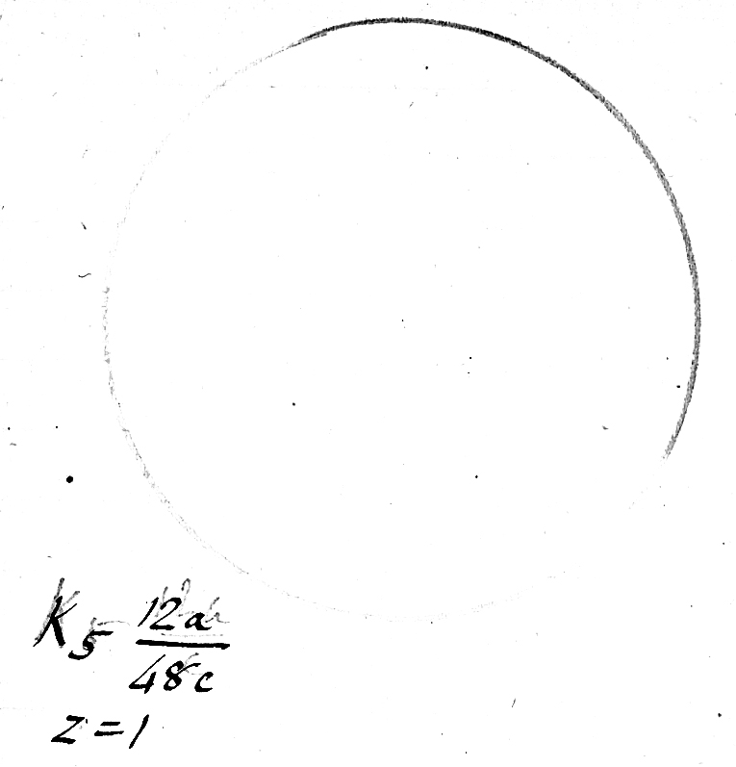
K₆ (1a/5c) z = 1 reduces to O₁ (6B/0C)
V₆ (2B/10C) K₆ (2a/10c) z = 2 reduces to I₁ (6B/6C)

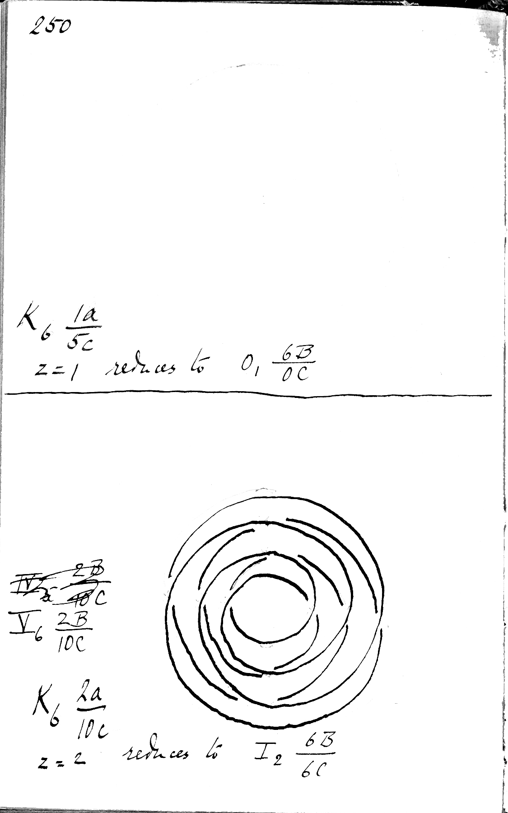
V₆ (3B/15C) K(sub 6) (3a/15c) z = 3 reduces to II₃ (6B/12C)
V₆ (4B/20C)
K₆ (4a/20c) z = 2 reduces to III₄ (6B/18C)

V₆ (5B/25C) reduces to IV₅ (6B/24C)
K₆ (5a/25c) = (reduced), K₅ (6a/24c) z = 1.

V₆ (6B/30C) K(sub 6) (6a/30c). z = 6.

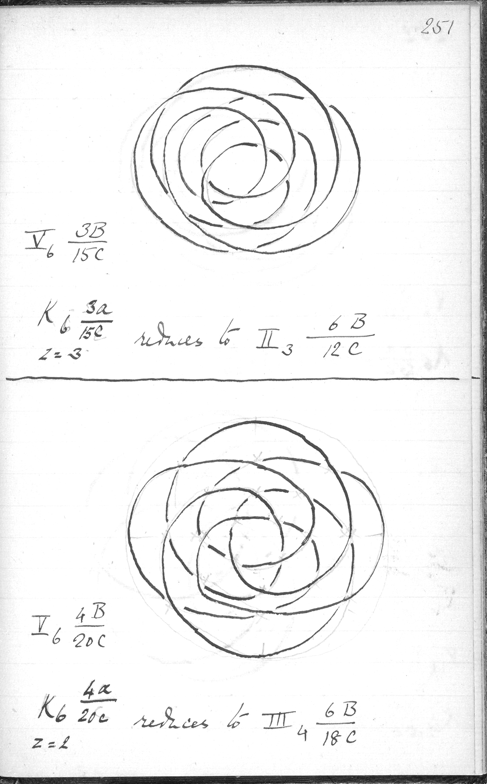

K₆ 7a⁄35c z = 1 = K_{7c} 6a⁄36c
K₆ 8a⁄40c z = 2

K₆ 9a⁄45c
z = 43
K₆10a⁄50c
z = 2

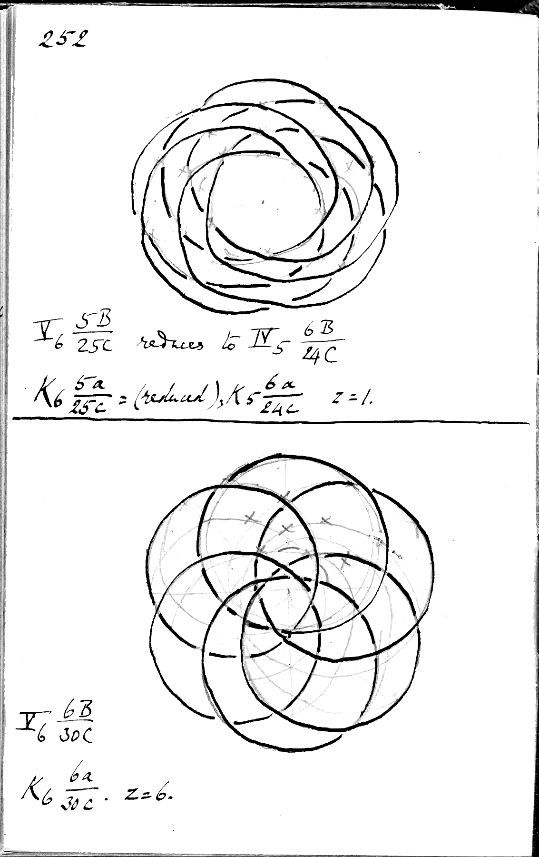
K₆ 11a⁄55c
z = 1]
K₆ 12a⁄60c
z = 6

S₇ 1B⁄6C

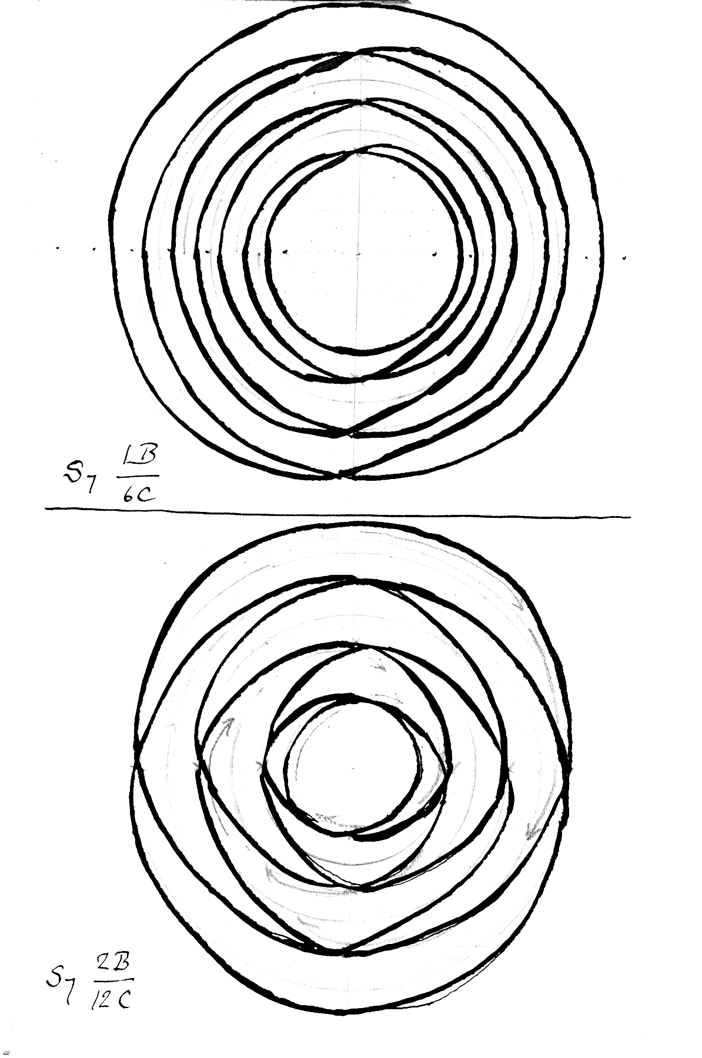

S₇ 2B⁄12C
It is better to leave breaks & put figures in I₇ as it is clearer.

S₇ 3B⁄18C

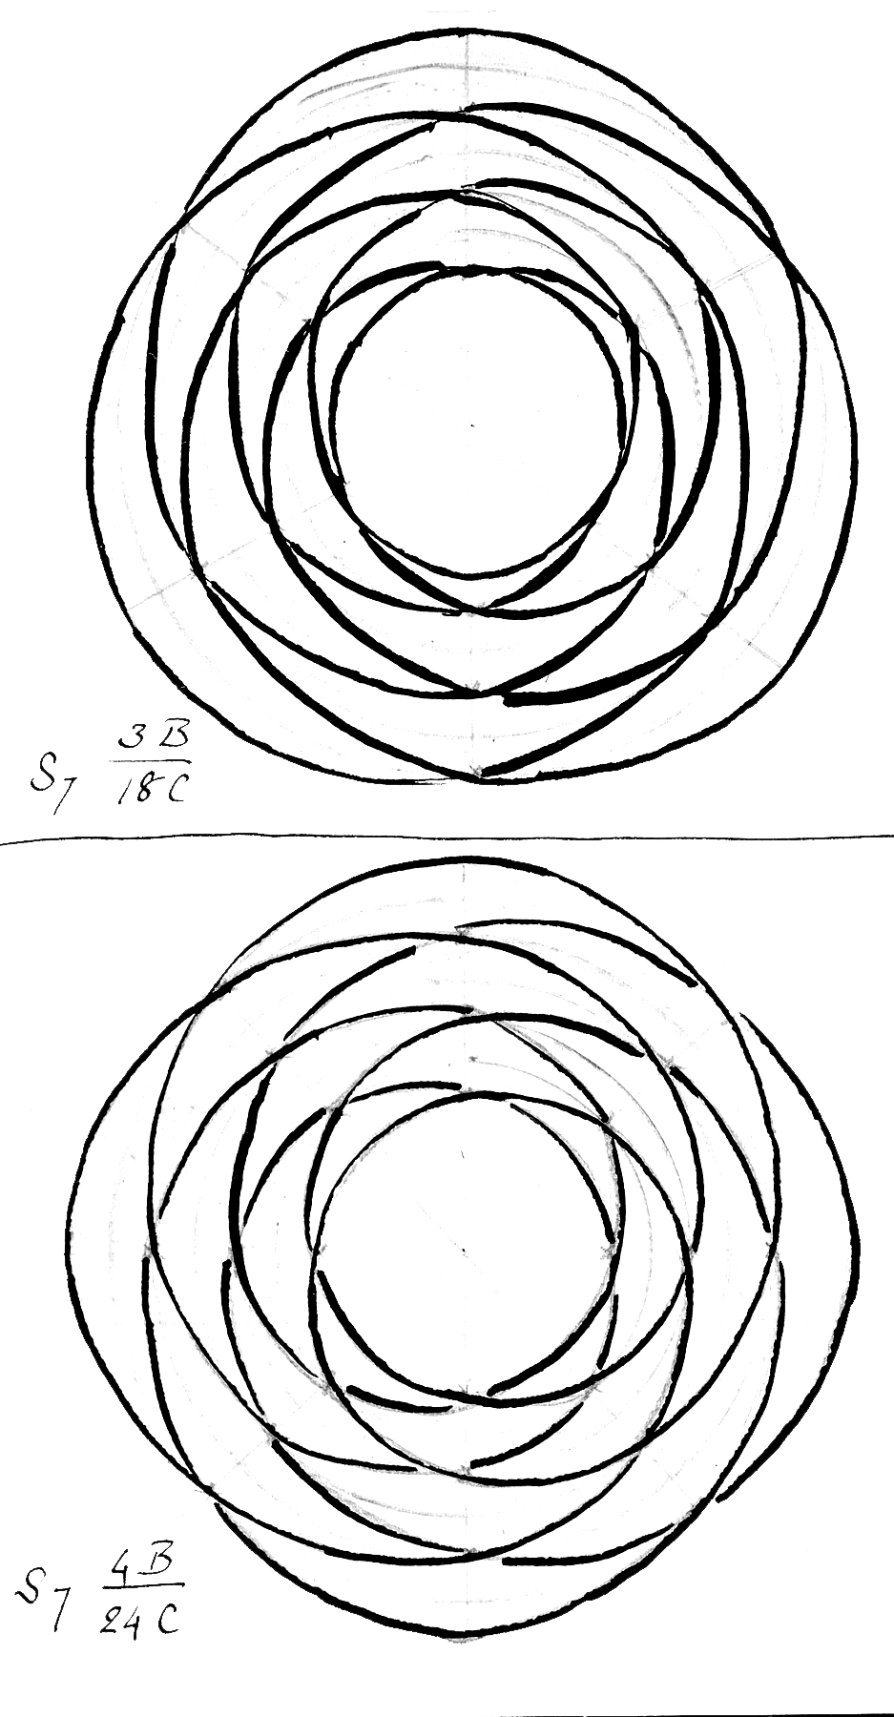

S₇ 4B⁄24C

A Theory of Torsion Knots founded mainly on the foregoing (original) diagrams.
(c.f. ii. P 257.)
(i) Knots such as are here called “Torsion Knots” are formed thus:- A number of cords are laid together in a parallel position equidistant from one another & an imaginary longitudinal axis. If the cords are laid at equal distances from one another along the surface of a flexible tube this arrangement would accord with the hypothesis. If this tube were now bent so that the ends joined the ends of each cord would be joined and a series of separate rings or bands of cord would result. But if before joining the ends of the tube it were twisted to the minimum extent necessary to bring the ends of those lying next to them respectively, a complication, here called a “Torsion Knot”, would result, and in such a case the tube would be said to have been twisted through one “arc”. If the twisting were such as to just suffice to bring the ends of alternate cords together, the tube would have been twisted through two “arcs”, and so on. The actual measure of the arc is of no importance, since all the arcs are equal, and can be easily calculated, with any given number of cords parallel & equidistant from one another on the surface of a tube. Thus with two cords, i & ii, a twist through one arc (180°) brings the ends of i & ii together. A twist through 2 arcs, brings the ends of i together & of ii together, & so on alternately. With 3 cords, i, ii, & iii, a twist of 1 arc brings the end of i on ii, ii on iii, & iii on i, & so on. (The arc here measures 120°)
(ii) However the cords are numbered & in whichever direction the cords are twisted, the resulting Torsion Knot will be the same, except that reversing the direction of twisting gives the reverse form of the knot. Hence it is not necessary to distinguish the individual cords by numbers.
(iii) The twisting must begin on the untwisted cords & continue for the required number of arcs uniformly in the same direction.
(iv) Torsion Knots can be arranged in series taking their index numbers from the number of original untwisted parallel equidistant cords, & these series are K₁, K₁ , K₃ & so on to K∞
(v.) Any series, K_{n}, will show in all the diagrams of knots belonging to it, n parts lying around the centre of a circle, n being a positive integer.
(vi) These diagrams are the same in any series K_{n} as in the Plait series (ii. ad fin) S_{n}, except that the crossings are governed by different rules. Thus the forms in the series K₃ correspond, knot for knot, with those in S₃ (ii.)
(vii) It follows that the crossings are the same in number, knot for knot, in the two groups, S & K.
(viii) The arcs in K equal the bights of the corresponding knot in S, and just as a knot in S can be represented by S_{n} b⁄c, so in K they are represented by K_{n} a⁄c, where a stands for arcs. (In neither case do these expressions indicate fractions.)
Thus the Torsion Knot corresponding to S₄ 6b⁄18c is K₄ 6a⁄18c.
It follows that in any series K_{n}, if the preceding series are known, no new knot can be found with a less than n, i.e. none before the first rings formed by a twist through 360° = n arcs. Thus in K₂₀ the first 19 knots have already appeared in K₀ to K₁₉.
(ix. α) Whereas in S all the crossings are alternate, in K they are in regular alternating sequences of (n-1) over & (n-1) under, n being the number of original untwisted cords in any series K_{n}.
(ix. β ) The resulting no. of cords after twisting on which the torsion knot appears is called z as in S, and z is the same, knot for knot, in both groups
(ix. γ) The analogy is so complete that the algebraical deductions made for S in ii.p263ff, apply mutatis mutandis to K.
(x.) Whereas in S all the knots are irreducible to knots with fewer crossings in every series in K (except K₁) Torsion Knots (in which a is less than n) are reducible to Torsion Knots
in a preceding series. The formula indicating the pairs of knots is:-
Formula of Reduction. x being less than n, then
K_{n} xa / x(n-1)c = K_{x} na / n(x-1)c
(or shortly, “K_{n} a⁄ gives K_{a} x⁄ ” : the rest follows.)
Further
seq 2, seq 0
K₃ 1a⁄2c = K₁ 3a⁄2c
seq 3, seq 1
K₄ 2a⁄6c = K₂ 4a⁄4c
seq 4, seq 2
K₅ 3a⁄12c = K₃ 5a⁄10c
& these were established by experiment, after which a general formula was substituted, containing “d”.
In applying this formula, the “denominations” of c may be disregarded since a (or b in S.) being given, c is established.
Thus :-
(1) K₂ 1a⁄1c = K₁ 2a⁄0c ii p230.
(2) K₃ 2a⁄4c = K₂ 3a⁄3c pp234 supr & ii.230.
(3) K₄ 3a⁄9c = K₃ 4a⁄8c pp238 & 234 supr.
(4) K₅ 4a⁄16c = K₄ 5a⁄15c pp245 & 239 supr.
(These identities were proved by experiment, & the formula, having been guessed from 2 & 3 was tested by 1 & 4, & considered established.)

The reduced knot is the knot of its series immediately following, & the reducible knot is that of its series immediately preceding the first “ring” knot (linked rings) and is always on 1 cord, for by rule xiv (ii. 269) when n and c⁄n-1 are prime to one another, z = 1. In the formula
C is always (n-1)2c.
Therefore if n & (n-1)2 c⁄(n-1) are prime to one another, z = 1. Therefore if n & (n-1) are so, z = 1. But these must be so (except when n = z). Hence z = 1. And when n = z, z also equals 1 (ii.230.)
The reduced knot therefore is on one cord also.
(xi) It is probable that all the other knots in any series Kn are irreducible.
(xii) Except that in K the crossings are governed by ix α supr. (p266) & that there is (one) reducible knot in every series, K & S are analogous in every way.
(xiii) S1 & K1, S2 & K2 are identical.

